**APPLICATION OF ARTIFICIAL INTELLIGENCE IN AGRICULTURAL INDUSTRIES - DEEP LEARNING - BASED PLANT DISEASE DETECTION SYSTEM**

A Project Report

Submitted in the partial fulfillment of the requirements

for the award of the degree of

**Master of Computer Applications**

In

**Department of Computer Science and Applications**

By

**TUMU LAKSHMAN PRASANNA KUMAR**

**(2301600039)**

Under the Supervision of

**Mr. J. A. JEVIN**

**Assistant Professor**



**Department of Computer Science and Applications**

**KONERU LAKSHMAIAH EDUCATIONAL FOUNDATION**

Green Fields, Vaddeswaram, Guntur District, A.P-522302. (2023-2025)

**KONERU LAKSHMAIAH EDUCATION FOUNDATION DEPARTMENT OF COMPUTER SCIENCE AND APPLICATIONS**



**DECLARATION**

The Project Report entitled **“PLANT DISEASE DETECTION USING ARTIFICIAL INTELLIGENCE”** is a record of bonafide work of **TUMU LAKSHMAN PRASANNA KUMAR**, submitted in partial fulfillment for the award of **Master of Computer Applications in Computer Science and Applications** of K L University. The results embodied in this report have not been copied from any other departments/University/Institute.

**Signature of the Student**

**TUMU LAKSHMAN PRASANNA KUMAR**

**(2301600039)**

**KONERU LAKSHMAIAH EDUCATION FOUNDATION DEPARTMENT OF COMPUTER SCIENCE AND APPLICATIONS**



**CERTIFICATE**

This is to certify that the Project Report entitled **“PLANT DISEASE DETECTION USING ARTIFICIAL INTELLIGENCE”** is being submitted by **TUMU LAKSHMAN PRASANNA KUMAR**, in partial fulfilment of the requirements for the award of **Master of Computer Applications** in **Computer Science and Applications** to the Koneru Lakshmaiah Education Foundation, is a record of Bonafide work carried out under our guidance and supervision.

The results embodied in this report have not been copied from any other departments/University/Institute.

**Mr. J. A. JEVIN Dr. CH. KIRAN KUMAR**

**Assistant Professor Professor & HOD Department**

**Department of CSA Department of CSA**

**Signature of the Examiner**

**ACKNOWLEDGEMENT**

I thankful to my guide, **Mr. J. A. Jevin, Assistant Professor, Department of CSA** for his valuable guidance and encouragement. His helping attitude and suggestions have helped in the successful completion of the project report.

I would like to express my gratefulness and sincere thanks to **Dr. Ch. Kiran Kumar, Head, Department of CSA**, for his kind help and encouragement during the course of study and in the successful completion of the project report.

I would like to express my heartful thanks to **Dr. K. Subramanyam, Principal** and **Department of CSA**, for successful completion of this project report, which cannot be done without proper support and encouragement.

I sincerely thanks to management for providing all the necessary facilities during course of study.

I would like to express my deep gratitude to all those who helped directly or indirectly to transform an idea in to working project.

**TUMU LAKSHMAN PRASANNA KUMAR**

**(2301600039)**

**PLANT DISEASE DETECTION USING ARTIFICIAL INTELLIGENCE**

# ****Abstract****

In the field of modern agriculture, **early and accurate detection of plant diseases** is critical to ensuring high crop productivity and reducing economic losses. Traditional methods of disease identification predominantly depend on **manual inspection and expert knowledge**, which are often **inaccessible**, **time-consuming**, and **subject to human error**, especially in **remote and resource-constrained areas**. The increasing demand for food security and sustainable farming necessitates intelligent, scalable, and cost-effective solutions to support plant health monitoring.

This project introduces the development of an **Artificial Intelligence (AI)-based plant disease detection system** that utilizes advanced **Deep Learning techniques**, specifically **image classification using Convolutional Neural Networks (CNNs)**. The system is designed to **automate the identification of tomato leaf diseases** through image analysis, thereby assisting **farmers, agronomists, and agricultural researchers** in making timely decisions for disease management and crop care.

A comprehensive dataset sourced from the **PlantVillage repository**—which includes thousands of images of **healthy and diseased tomato leaves** across various disease categories—is used to train and validate the model. The CNN model, built using **TensorFlow and Keras**, incorporates multiple convolutional and pooling layers to extract **deep, hierarchical features** from leaf images. The dataset undergoes preprocessing techniques such as resizing, normalization, and augmentation, followed by a structured split into training and validation sets to improve model generalization and accuracy. The trained model achieves a **high classification accuracy** and is saved in **.h5 format** for easy deployment and integration.

To ensure **real-world usability**, the trained model is deployed within a **Flask-based web application**, enabling users to upload images of affected leaves through a simple interface. Upon image upload, the system processes the image and performs disease classification in real-time. The output includes:

* The **predicted disease name**,
* The **model’s confidence score**, and
* **Curated treatment suggestions and plant growth tips**, retrieved from a structured disease_info.json knowledge base.

This AI system offers a **low-cost, scalable, and efficient** solution for real-time plant disease detection, particularly beneficial for smallholder farmers with limited access to agricultural extension services. Beyond tomato crops, the model and framework are designed to be **extensible to other plant species and diseases**, with future potential to integrate **mobile and drone-based camera systems** for large-scale, real-time field monitoring.

In conclusion, this project highlights the transformative potential of **Artificial Intelligence in agriculture**, demonstrating how **machine learning** and **web technologies** can be harnessed to **enhance crop health, optimize farm productivity, and promote sustainable agricultural practices** globally.

**Contents**

1. Aim 8

2. Introduction 10

3. Theoretical Background 12

3.1 Convolutional Neural Networks (CNNs) 12

3.2 Image Classification in Agriculture 13

3.3 Dataset: PlantVillage 13

3.4 Image Preprocessing and Augmentation 14

3.5 Model Evaluation Metrics 15

3.6 Technologies Used 15

4. Methodology 17

4.1 Tools and Technologies Used 17

4.2 Dataset Preparation 17

4.3 Model Architecture 18

4.4 Training the Model 21

4.5 Model Evaluation 21

4.6 Deployment Using Flask 21

4.7 Disease Knowledge Integration 21

5. Requirement Analysis 25

5.1 Functional Requirements 25

5.2 Non-Functional Requirements 25

5.3 User Requirements 26

5.4 Hardware and Software Requirements 26

5.5 Dataset Requirements 27

5.6 Integration Requirements 27

5.7 Constraints and Limitations 27

6. Software Design 29

6.1 Design Objectives 29

6.2 Architectural Design 29

6.3 Component Design 29

6.4 Data Flow Design 30

6.5 Model Integration Design 30

6.6 File Structure 30

6.7 Exception Handling 31

6.8 Security Considerations 31

6.9 Scalability and Extensibility 31

7. Code Implementation 33

7.1 Programming Language and Tools 33

7.2 Core Modules Overview 33

7.3 Supporting Files 37

7.4 Model Training (Optional Script) 37

7.5 Testing and Validation 38

8. Output Screens 70

8.1 Home Screen (Index Page) 70

8.2 Image Upload Validation 70

8.3 Prediction Result Screen 70

8.4 System Error or Server Issue Screen 71

8.5 Visual Snapshot Examples (Optional) 71

8.6 Recommendations for Better UI 74

9. Results and Discussion 75

10. Conclusion 79

11. Future Scope 81

11.1 Integration with Internet of Things (IoT) and Real-Time Monitoring 81

11.2 Mobile Application Deployment 81

11.3 Expansion of Dataset and Disease Coverage 81

11.4 Advanced Model Architectures 82

11.5 Integration with Weather and Environmental Data 82

11.6 Farmer Support Ecosystem 82

11.7 Research and Academic Contribution 82

11.8 Commercialization and Enterprise Use 83

Conclusion on Future Scope 83

12. References 84

12.1 Research Papers and Journals 84

12.2 Dataset Sources 84

12.3 Tools and Frameworks 84

12.4 Articles and Tutorials 85

12.5 Project Repository 85

Figure 1 Software Design 18

Figure 2 Sequence Diagram 20

Figure 3 Working Model Flowchart 23

Figure 4 Method Flowchart 24

Figure 5 Use Case Diagram, ER diagram, and System Architecture 28

Figure 6 Software Design 32

Figure 7 Home Page (index.html) 72

Figure 8 About Section 72

Figure 9 Upload Image 73

Figure 10 Image Upload Error 73

Figure 11 Successful Prediction Result 74

Figure 12 Contact Section 74

Figure 13 Model Accuracy 77

Figure 14 Model Loss 77

Figure 15 Confusion Matrix 77

Table 1 Tools and Purposes 17

# ****1. Aim****

The primary aim of this project is to design and implement an intelligent and user-friendly system that utilizes the capabilities of **Artificial Intelligence (AI)** and **Deep Learning**, particularly **Convolutional Neural Networks (CNNs)**, to accurately detect and classify various types of plant leaf diseases through image analysis. This AI-powered system is intended to assist **farmers, agriculturists, agronomists, and researchers** by providing a reliable, efficient, and automated method for identifying plant diseases from images of affected leaves.

By eliminating the need for traditional manual inspection or constant expert consultation—which can be time-consuming, costly, and error-prone—this system aims to **accelerate the disease diagnosis process**, enabling **faster decision-making and timely intervention**. Ultimately, the project seeks to promote **sustainable agriculture** by reducing crop losses, improving yield quality, and enhancing overall agricultural productivity.

**Objectives of the Project**

1. **To Develop a Robust Deep Learning Model for Disease Classification**
   * Implement a **Convolutional Neural Network (CNN)** architecture that is capable of learning intricate patterns and visual features from images of plant leaves.
   * The model will be trained to recognize and classify **multiple plant diseases** across different crop species with high precision, leveraging state-of-the-art deep learning techniques to achieve optimal performance.
2. **To Leverage the PlantVillage Dataset for Model Training and Evaluation**
   * Use the publicly available **PlantVillage dataset**, which contains thousands of annotated images of healthy and diseased plant leaves, as the primary dataset for model training and testing.
   * Perform data preprocessing, augmentation, and normalization to enhance model generalization and robustness across real-world scenarios.
3. **To Design a Web-Based Application Using Flask for User Interaction**
   * Develop an interactive, **web-based interface** using the **Flask web framework**, allowing users to upload images of affected plant leaves easily.
   * After image submission, the system will provide instant feedback including the **disease name, brief description, potential causes, suggested treatment methods**, and **growth improvement tips**.
   * Ensure that the web interface is **responsive, accessible, and easy to navigate** for users with minimal technical background.
4. **To Enhance Agricultural Productivity through Early Detection and Action**
   * Facilitate **early and accurate detection** of plant diseases, which is critical in preventing the spread of infection and mitigating economic losses.
   * Empower farmers and field workers to make **data-driven decisions** on pesticide use, crop management, and treatment plans without delay.
   * Support **precision agriculture practices** by promoting proactive rather than reactive crop care.

# ****2. Introduction****

**Overview of the Problem Statement**

Agriculture has long been the cornerstone of human civilization and remains a vital sector in the global economy. In many developing countries, agriculture serves as the primary livelihood for a significant portion of the population. The productivity and health of crops directly influence food availability, economic stability, and the well-being of rural communities. However, crop production is continuously threatened by various biotic and abiotic factors, with **plant diseases** being one of the most destructive and unpredictable elements.

Diseases not only **reduce crop yield** but also significantly **affect the quality** of agricultural produce, leading to severe economic losses for farmers and supply chain disruptions. Among the wide variety of crops cultivated globally, **tomatoes** hold a prominent position. They are extensively grown in tropical and temperate regions and are a critical component of diets worldwide due to their nutritional value and culinary versatility.

Tomato plants, however, are highly vulnerable to a wide range of diseases, including **Early Blight, Late Blight, Tomato Mosaic Virus, Bacterial Spot, and Septoria Leaf Spot**. These diseases can spread rapidly, especially in dense farming conditions, and often go unnoticed until significant damage has occurred. Timely and accurate identification is therefore essential for effective disease management and control.

Traditionally, farmers rely on **visual examination** of plant leaves and stems to identify signs of disease, often consulting with agricultural experts for confirmation. This method is **inherently subjective**, **time-consuming**, and **not scalable**, especially in large-scale agricultural operations or rural areas with **limited access to plant pathologists**. Additionally, the **similarity of visual symptoms** across different diseases can result in **misdiagnosis**, leading to **inappropriate treatment**, **increased pesticide usage**, and **further degradation of crop health**.

**Importance of Tomato Disease Detection in Agriculture**

Given the economic and nutritional significance of tomatoes, **early detection and intervention** in the case of disease outbreaks is critical. Diseases not only impact the **quantity** but also the **marketable quality** of tomato produce, affecting both local consumption and export potential. In a world with a **rapidly growing population** and **limited arable land**, ensuring healthy crop yields is more important than ever to meet food demands sustainably.

Efficient disease detection enables:

* **Timely treatment and control**, reducing the spread of infections.
* **Optimized use of agrochemicals**, minimizing environmental impact.
* **Lower production costs**, as crop loss and resource waste are minimized.
* **Improved decision-making**, where farmers are empowered with accurate and timely information.

The traditional diagnostic methods fall short in meeting these demands, thereby necessitating the integration of **automated, data-driven solutions** into modern agricultural practices. This is where **Artificial Intelligence** becomes a game-changer.

**Role of Artificial Intelligence and Deep Learning**

With the advancement of technology, **Artificial Intelligence (AI)** has emerged as a transformative force across various domains, and agriculture is no exception. Within AI, **Deep Learning (DL)**—a subfield that simulates the neural networks of the human brain—has demonstrated remarkable success in **image classification, pattern recognition, and predictive analytics**.

At the forefront of DL architectures is the **Convolutional Neural Network (CNN)**, a model specifically designed to analyze **visual imagery**. CNNs automatically learn to detect important features and patterns in images through multiple layers of abstraction, making them exceptionally well-suited for tasks such as **leaf disease identification**.

In this project, a CNN model is trained on a curated dataset of tomato leaf images encompassing various diseases and healthy conditions. The model learns to **extract discriminative features** such as color, texture, and shape anomalies that indicate disease presence. Unlike human inspection, the CNN can capture subtle differences that might be **invisible to the naked eye**, thereby **enhancing accuracy and reliability**.

This AI-driven approach drastically reduces the need for continuous human supervision and enables **real-time classification and diagnosis**. With proper deployment, the model can be integrated into **web or mobile applications**, allowing users, particularly farmers, to receive **instant feedback** by simply uploading a photo of the affected plant.

**Relevance of Computer Vision in Solving the Problem**

**Computer Vision**, a vital subdomain of AI, focuses on enabling machines to **interpret and process visual information** similarly to how humans perceive their environment. It has revolutionized various industries—ranging from healthcare and security to manufacturing—and is now playing a crucial role in **smart agriculture**.

In the context of this project, computer vision techniques are leveraged to **analyze digital images of tomato leaves**. By training the system on thousands of labeled samples, it becomes capable of **recognizing and classifying disease symptoms** with impressive precision. The application of computer vision not only supports **early disease diagnosis** but also enables **continuous plant monitoring** without requiring manual field inspection.

The technology supports the principles of **precision agriculture**, where data-driven insights guide the optimal use of resources such as fertilizers, water, and pesticides. This leads to:

* **Better yield and healthier crops**,
* **Reduced environmental impact**,
* **Minimized input costs**, and
* **Improved farmer autonomy**.

Computer vision, coupled with AI and deep learning, thus lays the foundation for a **sustainable, efficient, and intelligent agricultural ecosystem**. It transforms traditional farming into a modern, technologically-empowered practice capable of addressing global challenges in food production and environmental conservation.

# 3. Theoretical Background

This section delves into the theoretical concepts, machine learning techniques, and tools that form the foundation of the project titled **"AI-Based Plant Disease Detection using Deep Learning."** By integrating modern technologies such as Convolutional Neural Networks (CNNs), image classification, dataset preprocessing, and evaluation metrics, the system aims to intelligently classify plant diseases—particularly tomato leaf diseases—based on visual inputs.

## 3.1 Convolutional Neural Networks (CNNs)

**Convolutional Neural Networks (CNNs)** are a specialized type of deep neural network specifically designed for processing grid-like data such as images. CNNs have revolutionized the field of computer vision by achieving superior performance in tasks such as image classification, object detection, and image segmentation.

The strength of CNNs lies in their ability to automatically extract and learn **spatial hierarchies of features** from raw pixel data without the need for manual feature engineering. These models identify complex patterns by stacking multiple layers, each responsible for capturing increasingly abstract representations of the image.

**Key Layers in CNN Architecture:**

1. **Convolutional Layer:**
   * The primary building block of a CNN.
   * Applies a set of **learnable filters** (also called kernels) across the input image to extract local features such as **edges, textures, and shapes**.
   * The result is a **feature map** that highlights where certain features appear in the image.
2. **Activation Layer (ReLU - Rectified Linear Unit):**
   * Introduces **non-linearity** into the model.
   * Ensures that complex patterns can be learned by the network.
   * Converts all negative values to zero while keeping positive values intact, maintaining the spatial structure.
3. **Pooling Layer (MaxPooling):**
   * Performs **dimensionality reduction** by downsampling the feature maps.
   * **Max pooling** selects the maximum value from a region of the feature map, preserving the most prominent features.
   * Improves computational efficiency and makes the model **more robust to noise and spatial translations**.
4. **Fully Connected Layer (Dense Layer):**
   * Flattens the output from previous layers into a single vector.
   * Acts like a traditional neural network by connecting each neuron to every neuron in the next layer.
   * Used for **high-level reasoning and classification**.
5. **Dropout Layer:**
   * A regularization technique used during training to prevent **overfitting**.
   * Randomly disables a fraction of neurons in the network on each training iteration, forcing the model to learn redundant representations.
6. **Softmax Layer:**
   * Converts raw model outputs (logits) into **probability distributions** across classes.
   * Helps in determining the **most likely class** for a given input image.

## 3.2 Image Classification in Agriculture

**Image classification** is a fundamental task in computer vision where an algorithm learns to assign a **label** or **category** to an image based on its content. In agricultural applications, image classification allows machines to recognize diseases in plants by examining leaf patterns, color changes, and texture anomalies.

**Relevance in Agriculture:**

* Enables **automated plant health monitoring**.
* Reduces dependence on expert consultation.
* Supports **early detection and disease management**.

**How it Works:**

* The system is trained using **supervised learning**, where each image is tagged with a correct label (e.g., Early Blight, Mosaic Virus, or Healthy).
* A **Convolutional Neural Network** learns to classify unseen images based on patterns it has learned from training data.

## 3.3 Dataset: PlantVillage

The **PlantVillage dataset** is a publicly available and extensively used dataset for plant disease identification tasks. It plays a critical role in training robust deep learning models by providing a large volume of labeled image data.

**Key Features of the Dataset:**

* Contains over **54,000 high-resolution images** of plant leaves.
* Covers **14 different crop species**, including tomatoes, potatoes, corn, etc.
* Each image is labeled according to plant type, health status (healthy or diseased), and specific disease category.
* For tomatoes alone, there are several disease categories such as:
  + **Tomato Leaf Mold**
  + **Tomato Mosaic Virus**
  + **Tomato Yellow Leaf Curl Virus**
  + **Tomato Bacterial Spot**
* The dataset includes images taken under **controlled conditions**, which ensures clarity and uniformity, making it ideal for training deep learning models.

## 3.4 Image Preprocessing and Augmentation

Before feeding images into a CNN, it is essential to **preprocess** the raw data. This step ensures that all images are in a **consistent format**, reduces noise, and helps the model train faster and more effectively.

**Common Preprocessing Techniques:**

1. **Resizing:**
   * Images are resized to a fixed dimension (e.g., 64×64 or 299×299 pixels).
   * Ensures uniformity in the input shape expected by the model.
2. **Normalization:**
   * Pixel values are scaled to a range of **[0, 1]**.
   * Helps with faster convergence during training by maintaining consistent input distributions.
3. **Augmentation (Optional but Recommended):**
   * Artificially expands the dataset by generating modified versions of existing images.
   * Techniques include:
     + **Rotation**
     + **Horizontal/Vertical flipping**
     + **Zooming**
     + **Shearing**
     + **Brightness adjustment**
   * Augmentation improves the model’s **generalization capability** and prevents overfitting.

## 3.5 Model Evaluation Metrics

Evaluating a machine learning model is crucial to understanding its effectiveness and reliability. In classification problems like disease detection, relying solely on accuracy might be misleading, especially if the dataset is **imbalanced** (i.e., more healthy samples than diseased ones).

**Key Metrics Used:**

* **Accuracy:**  
  The proportion of total predictions that the model got correct.

Equation Accuracy:

$$Accuracy=\frac{Correct Predictions}{Total Predictions}$$ Accuracy = Correct Predictions / Total Predictions ​

* **Precision:**  
  Indicates how many of the predicted positive cases were actually correct.

Equation Precision

$$Precision=\frac{True Positives}{True Positives+False Negatives}$$

* **Recall (Sensitivity):**  
  Measures how many actual positives were correctly identified.

Equation Recall

$$Recall=\frac{True Positives}{True Positives+False Negatives}$$

* **F1 Score:**  
  Harmonic mean of Precision and Recall, providing a balanced metric.
* **Confusion Matrix:**  
  A 2D matrix showing the number of correct and incorrect predictions across all classes.
* **Loss Function (Categorical Crossentropy):**  
  Measures how far the predicted probabilities are from the actual labels. A lower loss indicates a better fit.

## 3.6 Technologies Used

The implementation of the project integrates various modern tools and libraries to achieve efficient and scalable results:

* **TensorFlow / Keras:**
  + Used for building, training, and evaluating deep learning models.
  + Offers high-level APIs (Keras) for rapid prototyping and experimentation.
* **OpenCV (Open Source Computer Vision Library):**
  + Used for image manipulation and preprocessing.
  + Facilitates reading, resizing, and visualizing images.
* **Flask:**
  + A lightweight Python web framework.
  + Used to develop the web interface where users can upload leaf images and receive disease predictions.
* **JSON (JavaScript Object Notation):**
  + Used to store disease-specific information such as:
    - **Name of the disease**
    - **Symptoms**
    - **Recommended treatment/cure**
    - **Plant growth tips**
  + Provides easy integration with the prediction pipeline for dynamic user feedback.

# 4. Methodology

This section comprehensively explains the step-by-step methodology adopted to build the **AI-Based Plant Disease Detection System** using deep learning techniques. The implementation pipeline involves dataset preparation, model construction, training and evaluation, web deployment, and integration of disease knowledge to provide useful agricultural insights.

## 4.1 Tools and Technologies Used

A variety of modern tools, libraries, and frameworks were utilized in the development of this project, each serving a specific purpose to ensure a smooth and scalable system.

| **Technology** | **Purpose** |
| --- | --- |
| **Python** | Core programming language used due to its extensive AI and ML libraries. |
| **TensorFlow / Keras** | For building and training Convolutional Neural Network (CNN) models. |
| **OpenCV** | Image processing, augmentation, and visualization. |
| **Flask** | Lightweight web framework for model deployment and creating the web UI. |
| **JSON** | Storing structured data about diseases such as cures and farming tips. |
| **PlantVillage Dataset** | Source of high-quality, labeled plant disease images for training the model. |

Table Tools and Purposes

## 4.2 Dataset Preparation

The dataset forms the backbone of the project, enabling the CNN model to learn various disease features from visual data. The **PlantVillage** dataset was chosen for its wide variety of annotated plant leaf images.

* **Dataset Source**: PlantVillage Dataset
* **Image Classes**: Includes multiple plant disease types like *Tomato Yellow Leaf Curl Virus*, *Late Blight*, *Leaf Mold*, and *Healthy* images.
* **Folder Structure**:

PlantVillage/

├── train/

│ ├── Healthy/

│ ├── Late_blight/

│ └── ...

└── val/

├── Healthy/

├── Late_blight/

└── ...

* **Data Handling Steps**:
  1. **Train-Validation Split**: Dataset was divided into training (80%) and validation (20%) folders.
  2. **Image Resizing**: All images were resized to 64×64 pixels for uniformity.
  3. **Normalization**: Pixel values were normalized to the range [0, 1] to speed up training.
  4. **Augmentation**: Random transformations such as rotation, zoom, and flipping were applied to increase dataset variability and prevent overfitting.

**Label Assignment**: Each folder name was mapped to a specific class label, enabling supervised learning.

## 4.3 Model Architecture

A deep learning model was architected using **Convolutional Neural Networks (CNNs)** with the **Keras Sequential API**. The structure was chosen for its high performance in image classification tasks.

* **Input Shape**: (64, 64, 3) RGB images.

**Software Design:**

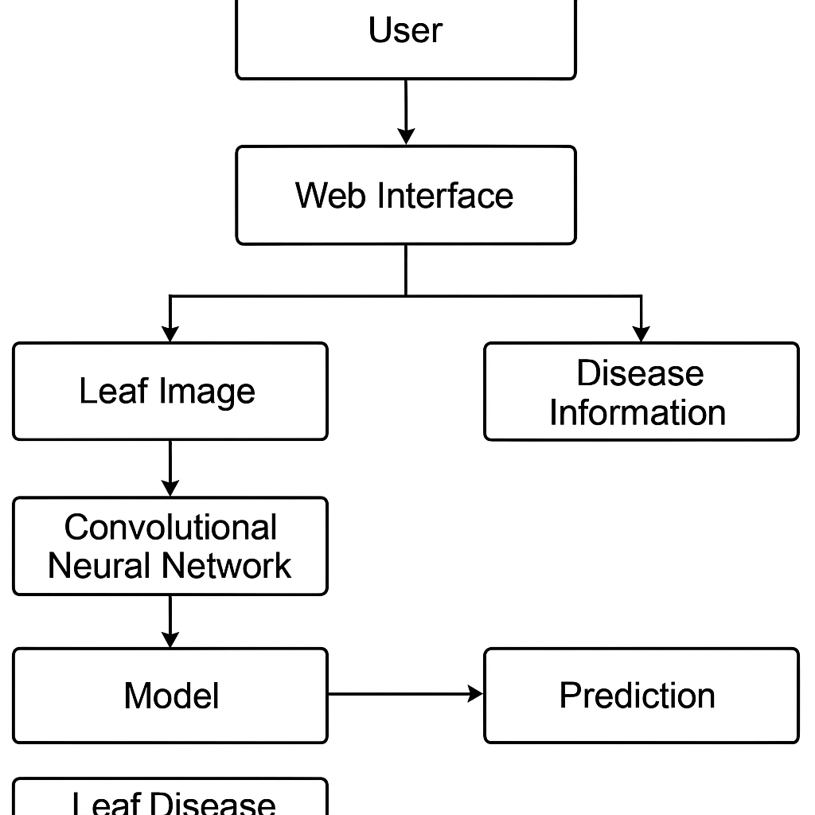

Figure Software Design

python

model = Sequential([

Input(shape=(64, 64, 3)),

Conv2D(32, (3, 3), activation='relu'),

MaxPooling2D(2, 2),

Conv2D(64, (3, 3), activation='relu'),

MaxPooling2D(2, 2),

Conv2D(128, (3, 3), activation='relu'),

MaxPooling2D(2, 2),

GlobalAveragePooling2D(),

Dense(128, activation='relu'),

Dropout(0.5),

Dense(num_classes, activation='softmax')

])

**SEQUENCE DIAGRAM:**

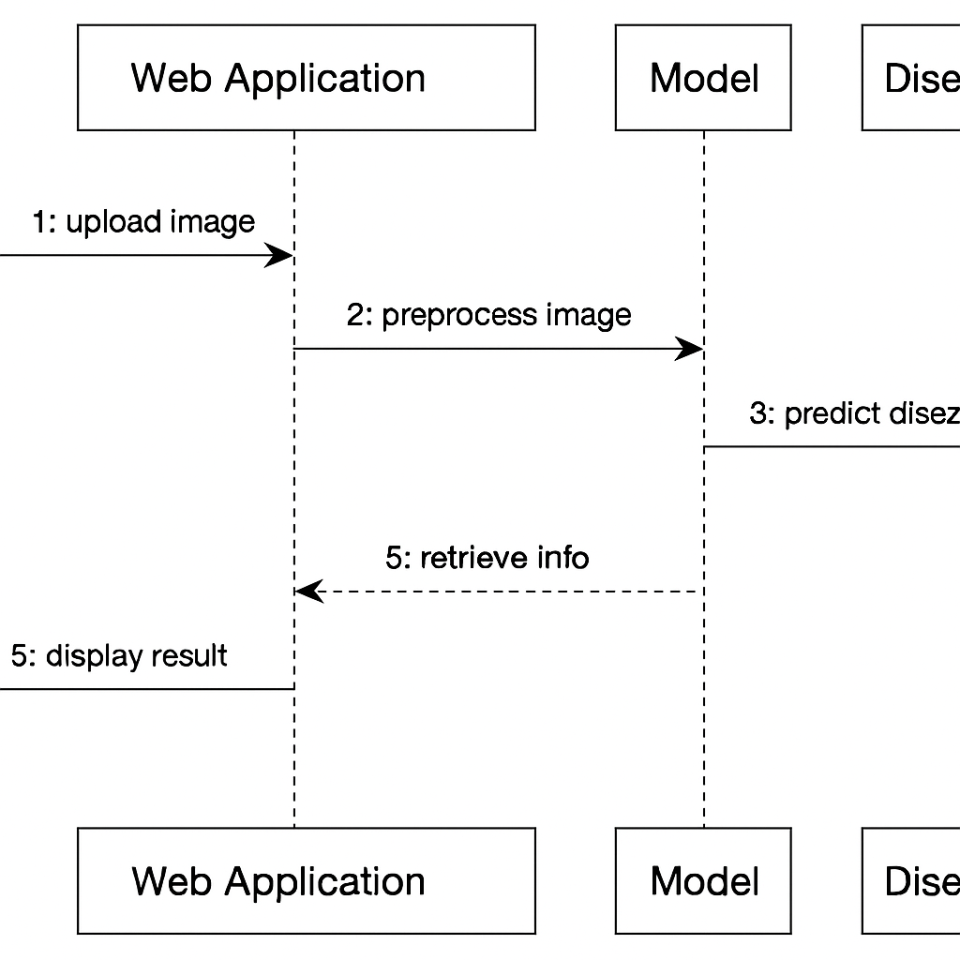

Figure Sequence Diagram

* **Key Elements**:
  + **Conv2D Layers**: Extract spatial features using learnable filters.
  + **MaxPooling2D**: Reduces feature map dimensions and computational load.
  + **GlobalAveragePooling2D**: Converts feature maps into a single vector.
  + **Dense Layer**: Performs final classification.
  + **Dropout**: Reduces overfitting by randomly disabling neurons during training.
  + **Softmax Layer**: Outputs class probabilities for multiclass classification.
* **Training Details**:
  + **Optimizer**: Adam for adaptive learning rate.
  + **Loss Function**: Categorical Crossentropy (used for multi-class classification).
  + **Evaluation Metric**: Accuracy.

## 4.4 Training the Model

The model was trained using a mini-batch approach for efficiency and convergence.

* **Training Configuration**:
  + **Batch Size**: 32
  + **Epochs**: 10 (adjustable based on convergence)
  + **Input Size**: 64×64 pixels RGB
  + **Steps Involved**:
    1. Set up ImageDataGenerator objects for both training and validation datasets with real-time data augmentation.
    2. Use the model.fit() function to train the model while monitoring both training and validation accuracy/loss.
    3. Implement callbacks to prevent overfitting and save the best-performing model.

## 4.5 Model Evaluation

After training, the model's performance was assessed using multiple evaluation techniques:

* **Accuracy**: The ratio of correctly predicted images to the total images.
* **Loss Curve**: Visualized training and validation loss to monitor overfitting.
* **Confusion Matrix**: Helped analyze class-wise performance and misclassification trends.
* **Precision and Recall**: Offered deeper insight into false positives/negatives, especially for underrepresented disease classes.
* **Error Analysis**: Examined misclassified images to identify areas for improvement.

## 4.6 Deployment Using Flask

To make the model accessible to end-users such as farmers or agricultural experts, a web application was developed using the **Flask** framework.

* **Deployment Workflow**:
  1. Flask server initializes and loads the trained model once at startup to ensure efficiency.
  2. User uploads a plant leaf image through the web interface.
  3. Image is preprocessed (resized to 299×299 for compatibility with other models like InceptionV3 if needed).
  4. Model predicts the disease class of the leaf.
  5. Prediction results are combined with disease information from the JSON file.
  6. Final results are rendered on result.html with the disease name, cure, and tips.

## 4.7 Disease Knowledge Integration

To enhance user experience and offer actionable advice, a **JSON-based metadata file** was created, mapping each disease class to its respective cure method and cultivation tips.

* **Example Structure**:

json

{

"Late Blight": {

"cure": "Apply fungicides and remove infected leaves.",

"growth_tips": "Ensure good air circulation and avoid overhead watering."

},

"Tomato Mosaic Virus": {

"cure": "Remove and destroy infected plants. Use resistant varieties.",

"growth_tips": "Avoid handling plants when wet. Sterilize tools."

}

}

* **Purpose**:
  + Educate farmers and agronomists about treatment.
  + Offer practical solutions to minimize crop loss.
  + Integrate AI predictions with agricultural domain knowledge.

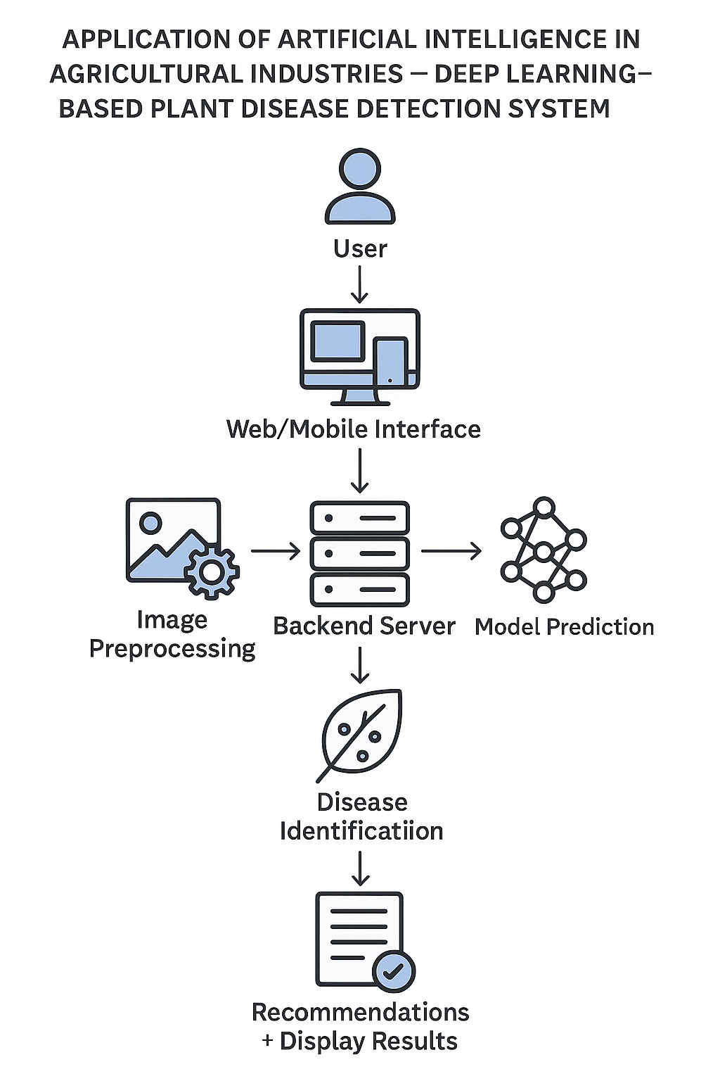

Figure Working Model Flowchart

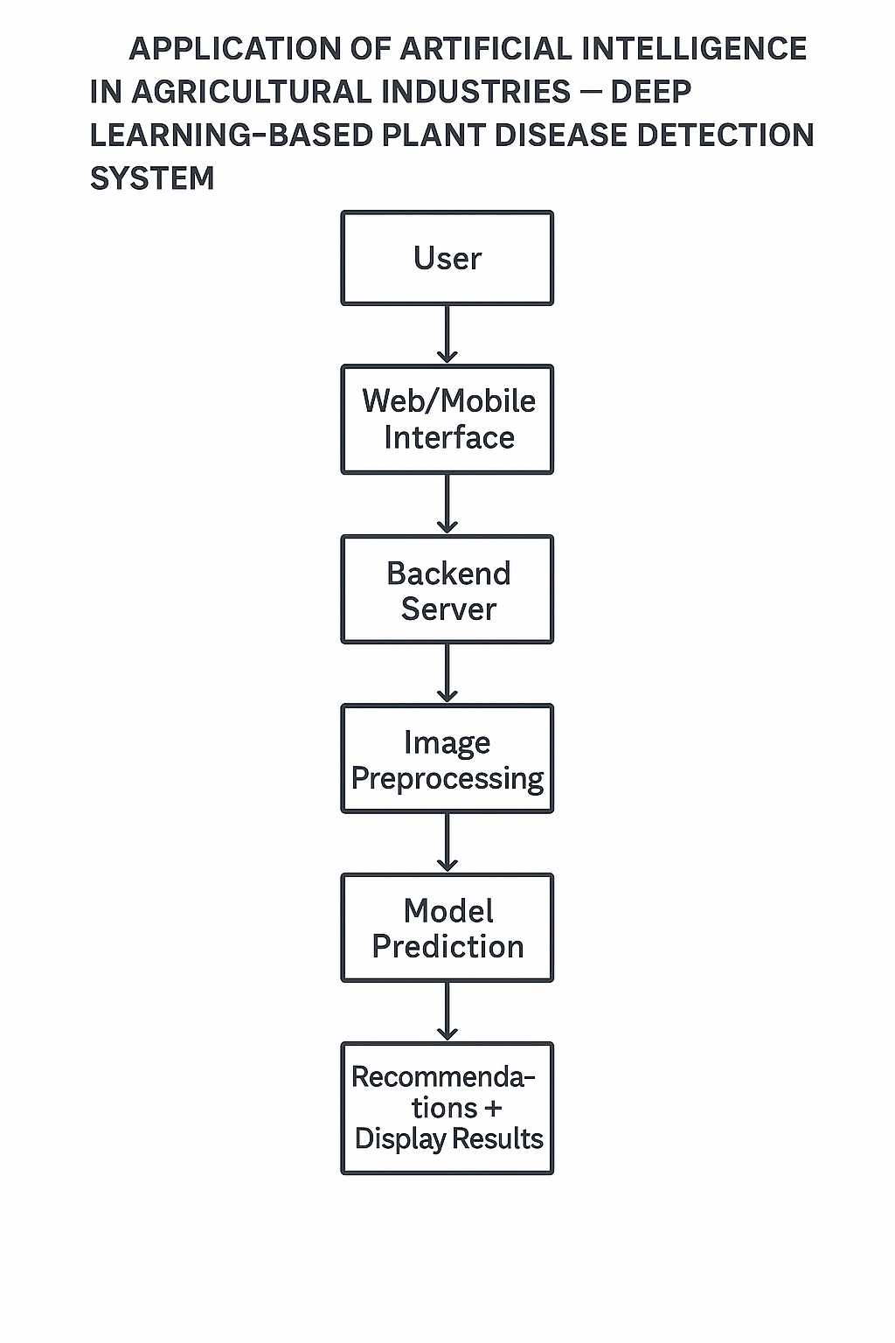

Figure Method Flowchart

# 5. Requirement Analysis

The success of any AI-based application depends heavily on a thorough requirement analysis. This section provides an in-depth assessment of the functional and non-functional requirements, system environment, stakeholder expectations, and necessary tools and technologies for the development and deployment of the Plant Disease Detection System.

## 5.1 Functional Requirements

Functional requirements describe what the system should do. For the plant disease detection system, these include:

**1. Image Upload and Processing**

* Users should be able to upload an image of a plant leaf through a web interface.
* The system must preprocess the uploaded image (resize, normalize, convert to a tensor) before feeding it to the deep learning model.

**2. Disease Detection and Prediction**

* The system must run inference using a trained Convolutional Neural Network (CNN) to detect the disease class.
* It must return the predicted class name with a confidence score.

**3. Display Treatment and Care Instructions**

* Based on the disease prediction, the system should retrieve relevant treatment methods and growth tips from a structured knowledge base (e.g., disease_info.json).

**4. Web Interface Interaction**

* Users must be able to interact with the application via a user-friendly web interface.
* The application must display:
  + The name of the disease
  + Confidence score
  + Treatment suggestions
  + Plant care recommendations

**5. Model Training and Update Capability**

* There must be support for retraining the model with new data.
* Class indices and disease data should be dynamically updatable as the dataset evolves.

## 5.2 Non-Functional Requirements

Non-functional requirements define the quality attributes of the system:

**1. Performance**

* The prediction process should respond in under 2 seconds for an uploaded image.
* The model should achieve high classification accuracy (preferably above 90%).

**2. Scalability**

* The system should be designed to support future extensions such as:
  + Integration with mobile apps
  + Real-time drone/camera feed processing
  + Additional plant species or disease types

**3. Usability**

* The web interface must be simple and intuitive for farmers with minimal technical knowledge.
* Clear instructions should guide users through uploading and interpreting results.

**4. Reliability**

* The system should work consistently across all major browsers and handle unexpected inputs gracefully (e.g., non-image files).

**5. Portability**

* The application must be deployable on local servers, cloud platforms (e.g., Heroku, AWS), or mobile devices (in future phases).

**6. Security**

* Input validation must be enforced to prevent malicious uploads.
* Only valid image formats (JPEG, PNG) should be accepted.

## 5.3 User Requirements

This project is primarily aimed at the following user groups:

* **Farmers and Agronomists**:
  + Need a fast, reliable way to diagnose plant diseases without expert consultation.
  + Should be able to use the app through smartphones or computers.
* **Researchers and Educators**:
  + May use the system for demonstration, research, or training purposes.
  + Should have access to model accuracy and confusion matrix data.
* **Agricultural Extension Officers**:
  + Can integrate the tool into community outreach programs to improve disease management.

## 5.4 Hardware and Software Requirements

**Hardware Requirements**

* Minimum:
  + CPU: Intel i5 or equivalent
  + RAM: 8 GB
  + Disk Space: 2 GB (for dataset, model, and dependencies)
* Recommended:
  + GPU (for model training): NVIDIA GTX 1650 or higher

**Software Requirements**

* OS: Windows/Linux/macOS
* Python 3.7+
* Required libraries:
  + TensorFlow/Keras
  + Flask
  + OpenCV
  + NumPy, Matplotlib, Pillow
  + JSON (for disease info mapping)

## 5.5 Dataset Requirements

* The **PlantVillage** dataset must be available in a structured format:

PlantVillage/

├── train/

│ ├── Healthy/

│ ├── Late_blight/

│ └── ...

└── val/

├── Healthy/

├── Late_blight/

└── ...

* Each folder must contain labeled images representing a specific plant disease class.
* The dataset must be augmented with transformations like:
  + Rotation
  + Zoom
  + Horizontal/vertical flip
  + Brightness adjustments

## 5.6 Integration Requirements

* The trained model must be integrated with the Flask backend using .h5 format.
* Disease-related metadata should be stored and fetched using class_indices.json and disease_info.json.
* The system must support RESTful API endpoints for prediction and data retrieval.

## 5.7 Constraints and Limitations

* **Image Quality Dependency**: The accuracy of predictions may drop with blurry or unclear images.
* **Disease Similarity**: Diseases with similar visual symptoms may be harder to differentiate.
* **Dataset Bias**: The model may perform poorly if tested on crops or diseases not included in the training data.

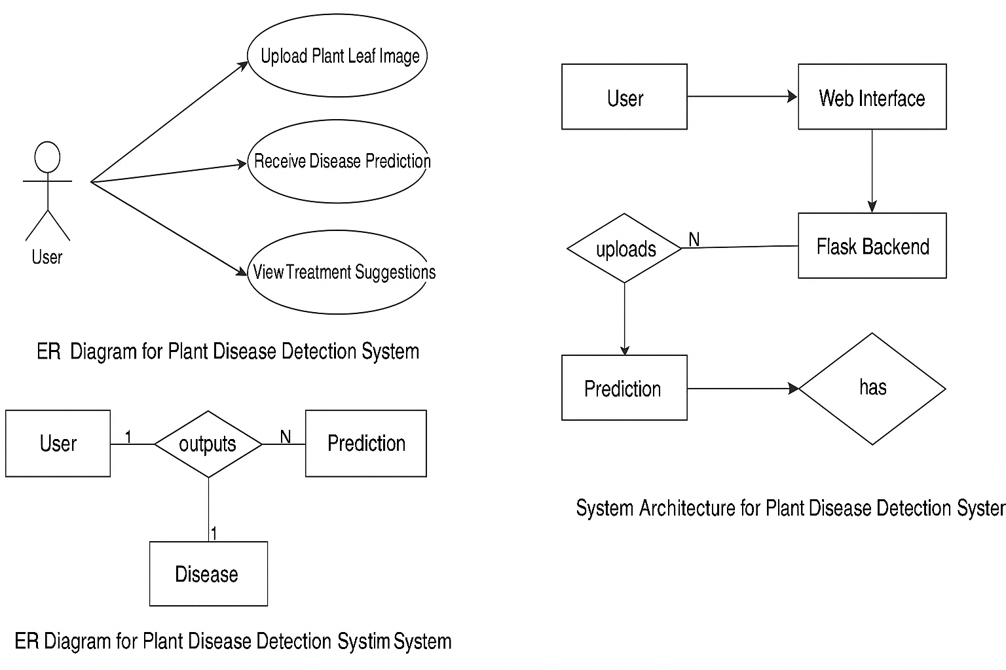

Figure Use Case Diagram, ER diagram, and System Architecture

# 6. Software Design

Software Software design is the blueprint for building a reliable and scalable system. It involves identifying system components, defining their responsibilities, and determining how they interact with one another. For the Plant Disease Detection System, the software design outlines the architectural structure, module design, data flow, and integration layers that make up the system.

## 6.1 Design Objectives

The primary objectives of the software design are:

* To ensure modular, scalable, and maintainable architecture
* To support rapid prediction of plant diseases from image inputs
* To present results through a user-friendly web interface
* To allow seamless interaction between frontend, backend, and machine learning components
* To ensure ease of integration with future components such as real-time detection or mobile apps

## 6.2 Architectural Design

The system follows a **three-tier architecture**:

**1. Presentation Layer (Frontend)**

* Developed using HTML, CSS, and JavaScript (with optional use of Bootstrap for styling).
* Allows users to upload plant leaf images.
* Displays predictions, confidence scores, and treatment information.

**2. Application Layer (Backend)**

* Implemented using **Flask** (a lightweight Python web framework).
* Handles user requests, routes them to appropriate services, and returns results.
* Contains core business logic for model inference and treatment recommendation.

**3. Data Layer**

* Comprises the pre-trained CNN model (model.h5), label mapping file (class_indices.json), and disease metadata (disease_info.json).
* Stores structured knowledge about diseases and treatments.

## 6.3 Component Design

**1. Image Upload Module**

* Accepts images in formats like JPG and PNG.
* Performs server-side validation (file type, size).
* Saves images temporarily for prediction.

**2. Preprocessing Module**

* Resizes image to target input size (e.g., 224x224).
* Normalizes pixel values and reshapes the image for model compatibility.
* Converts the image into a NumPy array or tensor for input to the CNN.

**3. Prediction Module**

* Loads the trained CNN model using Keras or TensorFlow.
* Processes the input image and performs inference.
* Maps prediction index to class label using class_indices.json.

**4. Treatment Suggestion Module**

* Loads disease-related metadata from disease_info.json.
* Extracts treatment suggestions and care tips based on predicted disease.
* Sends the response to the frontend.

**5. Result Display Module**

* Receives prediction result from backend.
* Renders the disease name, probability/confidence level, and treatment info.
* Offers visual cues to guide users (e.g., highlighting critical issues).

## 6.4 Data Flow Design

The data flow in the system can be summarized as follows:

1. **User uploads an image** via the web interface.
2. **Flask backend receives the image** and passes it to the preprocessing module.
3. **Preprocessed image is sent to the model** for disease prediction.
4. **Predicted class index is mapped** to a disease name.
5. **Treatment info is retrieved** from the local database.
6. **Final response is sent** to the frontend for rendering.

## 6.5 Model Integration Design

* The trained model is stored as model.h5.
* It is loaded once at server startup for efficiency.
* Predictions are performed using the Keras/TensorFlow predict method.
* Class indices are consistent with folder names in the training dataset.

## 6.6 File Structure

A well-organized file structure improves readability and maintainability. An example structure:

PlantDiseaseApp/

├── static/

│ └── css, js, and image assets

├── templates/

│ └── index.html, result.html

├── uploads/

│ └── temporarily stored images

├── model/

│ └── model.h5, class_indices.json

├── data/

│ └── disease_info.json

├── app.py

├── model.py

├── prediction.py

└── requirements.txt

## 6.7 Exception Handling

* **Invalid Image**: Prompt user to upload valid image formats.
* **Empty Submission**: Alert user when no file is selected.
* **Model Error**: Display generic error message and log the issue.
* **File I/O Error**: Handle missing or corrupted model files gracefully.

## 6.8 Security Considerations

* Limit file upload size to prevent abuse.
* Sanitize filenames to avoid injection attacks.
* Restrict upload types to images only.
* Store user uploads temporarily and remove them after processing.

## 6.9 Scalability and Extensibility

* The modular design allows future upgrades:
  + New diseases and plants can be added by retraining the model.
  + The frontend can be adapted for multilingual support.
  + Integration with mobile apps or APIs is straightforward due to RESTful design.Top of Form

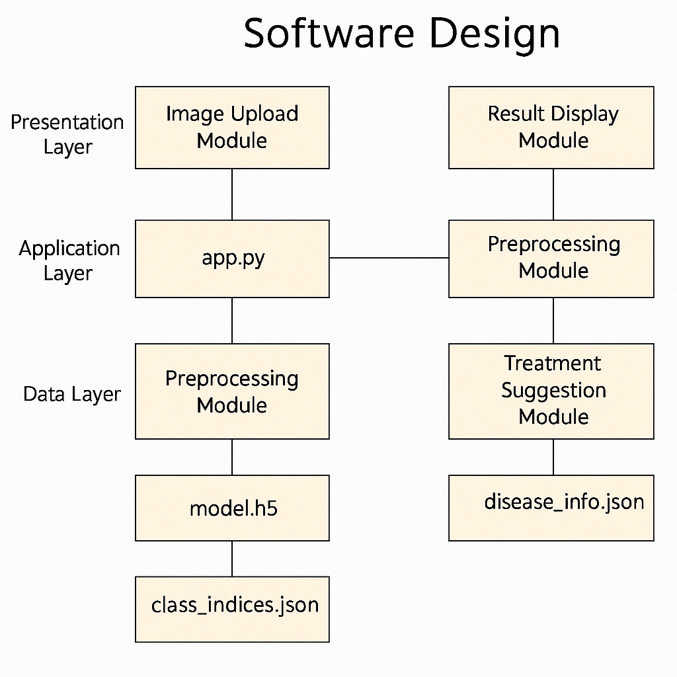

Figure Software Design

# 7. Code Implementation

The implementation phase transforms the system’s design into an operational program by writing and integrating code modules. For this project, Python is used as the core programming language along with Flask for web development and TensorFlow/Keras for deep learning.

This section explains the key code modules and their responsibilities, supported by implementation logic.

## 7.1 Programming Language and Tools

* **Programming Language:** Python 3.x
* **Framework:** Flask (for web development)
* **Libraries Used:**
  + TensorFlow / Keras (for deep learning model inference)
  + OpenCV, NumPy (for image preprocessing)
  + Pillow (for image handling)
  + JSON (for reading metadata and class mappings)
  + WTForms / Flask-WTF (optional, for form validation)
* **Environment:** Jupyter Notebook (for training), PyCharm or VSCode (for deployment)

## 7.2 Core Modules Overview

**1. model.py – Model Loading and Configuration**

This module is responsible for loading the trained model and storing helper functions such as prediction routines.

**Key Responsibilities:**

* Load the .h5 model file
* Load and store class indices
* Define image preprocessing steps
* Run model inference

python

from keras.models import load_model

import numpy as np

from tensorflow.keras.preprocessing import image

import json

model = load_model('model.h5')

with open('class_indices.json', 'r') as f:

class_indices = json.load(f)

def predict_image(img_path):

img = image.load_img(img_path, target_size=(224, 224))

img_array = image.img_to_array(img) / 255.0

img_array = np.expand_dims(img_array, axis=0)

prediction = model.predict(img_array)[0]

predicted_class = np.argmax(prediction)

confidence = round(prediction[predicted_class] * 100, 2)

return class_indices[str(predicted_class)], confidence

**2. disease_info.json – Disease Metadata File**

Stores treatment tips, descriptions, and prevention methods for each disease class.

**Example Format:**

json

{

"Tomato___Late_blight": {

"description": "A fungal disease caused by Phytophthora infestans.",

"treatment": "Use copper-based fungicides. Remove infected leaves.",

"prevention": "Avoid overhead watering and overcrowding of plants."

}

}

**3. app.py – Flask Web Application**

Acts as the entry point to the application. Handles routing, image upload, and integrates model and metadata response.

**Key Functionalities:**

* Home page rendering
* Image upload and validation
* Calling the model and retrieving treatment suggestions
* Displaying results on a new page

python

from flask import Flask, request, render_template

from model import predict_image

import json

import os

app = Flask(__name__)

UPLOAD_FOLDER = 'uploads'

app.config['UPLOAD_FOLDER'] = UPLOAD_FOLDER

with open('disease_info.json', 'r') as f:

disease_info = json.load(f)

@app.route('/')

def index():

return render_template('index.html')

@app.route('/predict', methods=['POST'])

def predict():

if 'image' not in request.files:

return "No file uploaded", 400

img_file = request.files['image']

if img_file.filename == '':

return "No selected file", 400

img_path = os.path.join(app.config['UPLOAD_FOLDER'], img_file.filename)

img_file.save(img_path)

predicted_class, confidence = predict_image(img_path)

info = disease_info.get(predicted_class, {})

return render_template('result.html',

prediction=predicted_class,

confidence=confidence,

description=info.get("description", "N/A"),

treatment=info.get("treatment", "N/A"),

prevention=info.get("prevention", "N/A"))

**4. templates/index.html – Image Upload Interface**

html

<!DOCTYPE html>

<html>

<head>

<title>Plant Disease Detector</title>

</head>

<body>

<h1>Upload Plant Leaf Image</h1>

<form method="POST" action="/predict" enctype="multipart/form-data">

<input type="file" name="image" accept="image/*" required><br><br>

<input type="submit" value="Diagnose">

</form>

</body>

</html>

**5. templates/result.html – Results Display Page**

html

<!DOCTYPE html>

<html>

<head>

<title>Prediction Result</title>

</head>

<body>

<h2>Prediction: {{ prediction }}</h2>

<p>Confidence: {{ confidence }}%</p>

<h3>Description</h3>

<p>{{ description }}</p>

<h3>Treatment</h3>

<p>{{ treatment }}</p>

<h3>Prevention</h3>

<p>{{ prevention }}</p>

<a href="/">Try Another Image</a>

</body>

</html>

## 7.3 Supporting Files

* **requirements.txt**: Lists all Python libraries for setting up the environment.
* **uploads/**: Stores temporarily uploaded images.
* **static/**: Contains custom CSS or JavaScript files if styling is added.

## 7.4 Model Training (Optional Script)

Training script (if needed) may include:

python

from tensorflow.keras.preprocessing.image import ImageDataGenerator

from tensorflow.keras.models import Sequential

from tensorflow.keras.layers import Conv2D, MaxPooling2D, Flatten, Dense

import json

model = Sequential([

Conv2D(32, (3, 3), activation='relu', input_shape=(224, 224, 3)),

MaxPooling2D(2, 2),

Flatten(),

Dense(64, activation='relu'),

Dense(15, activation='softmax') # Adjust based on number of classes

])

model.compile(optimizer='adam', loss='categorical_crossentropy', metrics=['accuracy'])

train_datagen = ImageDataGenerator(rescale=1./255)

train_generator = train_datagen.flow_from_directory('PlantVillage/train', target_size=(224, 224))

model.fit(train_generator, epochs=10)

model.save('model.h5')

# Save class indices

with open('class_indices.json', 'w') as f:

json.dump(train_generator.class_indices, f)

## 7.5 Testing and Validation

* Each module is unit tested with sample input images.
* Predictions are verified against known labels.
* Exception handling is tested for missing or invalid files.
* UI validation is implemented to ensure only images are accepted.

**App.py**

from flask import Flask, render_template, request, jsonify

import tensorflow as tf

import numpy as np

from tensorflow.keras.preprocessing import image

import os

import json

# Initialize Flask app

app = Flask(__name__)

# Uploads folder

UPLOAD_FOLDER = "uploads"

os.makedirs(UPLOAD_FOLDER, exist_ok=True)

# Paths

BASE_DIR = os.path.dirname(os.path.abspath(__file__))

MODEL_PATH = os.path.join(BASE_DIR, "model", "plant_disease_model.h5")

CLASS_INDEX_PATH = os.path.join(BASE_DIR, "class_indices.json")

# Load the model

if not os.path.exists(MODEL_PATH):

    raise FileNotFoundError(f"⚠️ Model not found at {MODEL_PATH}")

model = tf.keras.models.load_model(MODEL_PATH)

# Load class index map

if not os.path.exists(CLASS_INDEX_PATH):

    raise FileNotFoundError(f"⚠️ class_indices.json not found at {CLASS_INDEX_PATH}")

with open(CLASS_INDEX_PATH, 'r', encoding='utf-8') as f:

    class_indices = json.load(f)

# Build index-to-label mapping

index_to_label = {int(k): v["name"] for k, v in class_indices.items()}

disease_info = {

    v["name"].lower(): {

        "cure": v.get("cure", "No information available."),

        "growth_tips": v.get("growth_tips", "No information available.")

    }

    for v in class_indices.values()

}

# Image preprocessing function

def preprocess_image(img_path):

    img = image.load_img(img_path, target_size=(64, 64))  # Match training size

    img_array = image.img_to_array(img)

    img_array = np.expand_dims(img_array, axis=0)

    return img_array / 255.0

# Home route

@app.route('/')

def home():

    return render_template('index.html')

# Predict route

@app.route('/predict', methods=['POST'])

def predict():

    if 'file' not in request.files:

        return jsonify({"error": "No file uploaded"}), 400

    file = request.files['file']

    if file.filename == '':

        return jsonify({"error": "No file selected"}), 400

    file_path = os.path.join(UPLOAD_FOLDER, file.filename)

    file.save(file_path)

    try:

        img_array = preprocess_image(file_path)

        prediction = model.predict(img_array)

        predicted_index = int(np.argmax(prediction))

        predicted_class = index_to_label.get(predicted_index, "Unknown")

        confidence = round(float(np.max(prediction)) * 100, 2)

        info = disease_info.get(predicted_class.lower(), {

            "cure": "No information available.",

            "growth_tips": "No information available."

        })

        if info["cure"] == "No information available.":

            print(f"⚠️ Missing info for: {predicted_class}")

        return render_template(

            'result.html',

            prediction=predicted_class,

            confidence=f"{confidence}%",

            cure=info["cure"],

            growth_tips=info["growth_tips"]

        )

    except Exception as e:

        return jsonify({"error": str(e)}), 500

# Run the app

if __name__ == '__main__':

    app.run(debug=True)

**train.py**

import os

import json

import tensorflow as tf

from tensorflow.keras.preprocessing.image import ImageDataGenerator

from tensorflow.keras.models import Sequential

from tensorflow.keras.layers import Conv2D, MaxPooling2D, GlobalAveragePooling2D, Dense, Dropout, Input

from tensorflow.keras.optimizers import Adam

# Paths

BASE_DIR = os.path.dirname(os.path.abspath(__file__))

DATASET_PATH = os.path.join(BASE_DIR, 'PlantVillage')

TRAIN_DIR = os.path.join(DATASET_PATH, 'train')

VAL_DIR = os.path.join(DATASET_PATH, 'val')

DISEASE_INFO_PATH = os.path.join(BASE_DIR, 'disease_info.json')

MODEL_DIR = os.path.join(BASE_DIR, 'model')

MODEL_SAVE_PATH = os.path.join(MODEL_DIR, 'plant_disease_model.h5')

CLASS_INDEX_PATH = os.path.join(BASE_DIR, 'class_indices.json')

# Create model directory if it doesn't exist

os.makedirs(MODEL_DIR, exist_ok=True)

# Image settings

IMAGE_SIZE = (64, 64)

BATCH_SIZE = 32

EPOCHS = 10

# Data generators

train_datagen = ImageDataGenerator(rescale=1. / 255)

val_datagen = ImageDataGenerator(rescale=1. / 255)

train_generator = train_datagen.flow_from_directory(

    TRAIN_DIR,

    target_size=IMAGE_SIZE,

    batch_size=BATCH_SIZE,

    class_mode='categorical'

)

val_generator = val_datagen.flow_from_directory(

    VAL_DIR,

    target_size=IMAGE_SIZE,

    batch_size=BATCH_SIZE,

    class_mode='categorical'

)

# Model definition

model = Sequential([

    Input(shape=(64, 64, 3)),

    Conv2D(32, (3, 3), activation='relu'),

    MaxPooling2D(2, 2),

    Conv2D(64, (3, 3), activation='relu'),

    MaxPooling2D(2, 2),

    Conv2D(128, (3, 3), activation='relu'),

    MaxPooling2D(2, 2),

    GlobalAveragePooling2D(),

    Dense(128, activation='relu'),

    Dropout(0.5),

    Dense(train_generator.num_classes, activation='softmax')

])

model.compile(optimizer=Adam(), loss='categorical_crossentropy', metrics=['accuracy'])

# Save class indices with consistent key types (str keys for JSON compatibility)

class_indices = train_generator.class_indices

disease_info = {}

# Load disease info

with open(DISEASE_INFO_PATH, 'r', encoding='utf-8') as f:

    disease_info_data = json.load(f)

# Build final class index info

for disease, index in class_indices.items():

    disease_info[str(index)] = {

        "name": disease,

        "cure": disease_info_data.get(disease, {}).get("cure", "No data"),

        "growth_tips": disease_info_data.get(disease, {}).get("growth_tips", "No data")

    }

# Save class index mapping

with open(CLASS_INDEX_PATH, 'w', encoding='utf-8') as f:

    json.dump(disease_info, f, indent=4, ensure_ascii=False)

# Train the model

history = model.fit(

    train_generator,

    steps_per_epoch=len(train_generator),

    epochs=EPOCHS,

    validation_data=val_generator,

    validation_steps=len(val_generator)

)

# Save the model

model.save(MODEL_SAVE_PATH)

print("✅ Training complete. Model saved to", MODEL_SAVE_PATH)

print("✅ Class indices saved to", CLASS_INDEX_PATH)

**class_indices.json**

{

    "0": {

        "name": "Alternaria Leaf Spot",

        "cure": "Apply fungicides with chlorothalonil or mancozeb.",

        "growth_tips": "Avoid prolonged leaf wetness and improve air circulation."

    },

    "1": {

        "name": "Anthracnose",

        "cure": "Use a fungicide with azoxystrobin. Remove infected plant debris.",

        "growth_tips": "Practice crop rotation and avoid overhead watering."

    },

    "2": {

        "name": "Bacterial Leaf Blight",

        "cure": "Apply copper-based sprays and remove infected plants.",

        "growth_tips": "Ensure proper plant spacing and avoid high humidity."

    },

    "3": {

        "name": "Bacterial Wilt",

        "cure": "Remove and destroy affected plants. Use resistant varieties.",

        "growth_tips": "Ensure proper soil drainage and avoid overwatering."

    },

    "4": {

        "name": "Black Rot",

        "cure": "Apply copper fungicides and remove affected leaves.",

        "growth_tips": "Use disease-free seeds and avoid overhead watering."

    },

    "5": {

        "name": "Blight",

        "cure": "Apply a copper fungicide and remove infected plant parts.",

        "growth_tips": "Rotate crops and avoid planting in the same soil yearly."

    },

    "6": {

        "name": "Brown Spot",

        "cure": "Use copper-based fungicides and remove infected leaves.",

        "growth_tips": "Ensure good drainage and avoid overhead irrigation."

    },

    "7": {

        "name": "Cercospora Leaf Spot",

        "cure": "Apply neem oil or copper fungicides.",

        "growth_tips": "Improve soil drainage and reduce plant stress."

    },

    "8": {

        "name": "Damping-Off",

        "cure": "Remove and destroy affected seedlings. Avoid overwatering and ensure good air circulation. Use fungicide-treated seeds or apply soil fungicides like captan or metalaxyl.",

        "growth_tips": "Use sterile, well-draining soil and avoid planting seeds too densely. Water in the morning to allow soil surface to dry and provide adequate light and ventilation."

    },

    "9": {

        "name": "Downy Mildew",

        "cure": "Apply fungicides like metalaxyl or copper-based sprays.",

        "growth_tips": "Ensure good air movement and reduce humidity around plants."

    },

    "10": {

        "name": "Early Blight",

        "cure": "Apply chlorothalonil or copper-based fungicides.",

        "growth_tips": "Mulch around plants to prevent soil splash."

    },

    "11": {

        "name": "Fusarium Wilt",

        "cure": "Use fungicides containing thiophanate-methyl. Rotate crops.",

        "growth_tips": "Improve soil health and avoid planting in contaminated areas."

    },

    "12": {

        "name": "Gray Mold",

        "cure": "Use fungicides like iprodione or thiophanate-methyl.",

        "growth_tips": "Increase airflow and remove dead plant material."

    },

    "13": {

        "name": "Healthy",

        "cure": "No treatment required. Maintain optimal watering and fertilization.",

        "growth_tips": "Ensure proper sunlight and regular pruning for better growth."

    },

    "14": {

        "name": "Leaf Curl",

        "cure": "Apply fungicides before bud break, such as Bordeaux mixture.",

        "growth_tips": "Use disease-resistant varieties and prune infected areas."

    },

    "15": {

        "name": "Leaf Spot",

        "cure": "Use fungicidal sprays and remove infected leaves promptly.",

        "growth_tips": "Water plants at the base and avoid wetting the leaves."

    },

    "16": {

        "name": "Mosaic Virus",

        "cure": "No chemical cure. Remove and destroy infected plants.",

        "growth_tips": "Control aphids and other pests that spread the virus."

    },

    "17": {

        "name": "Powdery Mildew",

        "cure": "Use fungicides containing sulfur or neem oil. Remove affected leaves.",

        "growth_tips": "Ensure proper air circulation and avoid overhead watering."

    },

    "18": {

        "name": "Rust",

        "cure": "Apply copper-based fungicides. Remove infected leaves to prevent spread.",

        "growth_tips": "Plant resistant varieties and maintain proper spacing."

    },

    "19": {

        "name": "Scab",

        "cure": "Apply fungicides containing sulfur or captan.",

        "growth_tips": "Use resistant plant varieties and prune regularly."

    },

    "20": {

        "name": "Septoria Leaf Spot",

        "cure": "Use fungicides with chlorothalonil or copper compounds.",

        "growth_tips": "Avoid excessive nitrogen fertilization and water at the base."

    },

    "21": {

        "name": "Sooty Mold",

        "cure": "Control the insects that cause mold buildup (e.g., aphids, whiteflies).",

        "growth_tips": "Use insecticidal soap and keep plants clean from honeydew."

    },

    "22": {

        "name": "Verticillium Wilt",

        "cure": "No effective treatment. Remove infected plants and improve soil.",

        "growth_tips": "Use disease-resistant varieties and improve soil aeration."

    },

    "23": {

        "name": "White Mold",

        "cure": "Apply fungicides like thiophanate-methyl and remove affected plants.",

        "growth_tips": "Improve soil drainage and avoid excessive moisture."

    },

    "24": {

        "name": "Yellow Leaf Curl Virus",

        "cure": "No cure available. Remove infected plants to prevent spread.",

        "growth_tips": "Control whiteflies as they spread the virus."

    }

}

**disease_info.json**

{

    "Healthy": {

        "cure": "No treatment required. Maintain optimal watering and fertilization.",

        "growth_tips": "Ensure proper sunlight and regular pruning for better growth."

    },

    "Powdery Mildew": {

        "cure": "Use fungicides containing sulfur or neem oil. Remove affected leaves.",

        "growth_tips": "Ensure proper air circulation and avoid overhead watering."

    },

    "Rust": {

        "cure": "Apply copper-based fungicides. Remove infected leaves to prevent spread.",

        "growth_tips": "Plant resistant varieties and maintain proper spacing."

    },

    "Leaf Spot": {

        "cure": "Use fungicidal sprays and remove infected leaves promptly.",

        "growth_tips": "Water plants at the base and avoid wetting the leaves."

    },

    "Blight": {

        "cure": "Apply a copper fungicide and remove infected plant parts.",

        "growth_tips": "Rotate crops and avoid planting in the same soil yearly."

    },

    "Bacterial Wilt": {

        "cure": "Remove and destroy affected plants. Use resistant varieties.",

        "growth_tips": "Ensure proper soil drainage and avoid overwatering."

    },

    "Early Blight": {

        "cure": "Apply chlorothalonil or copper-based fungicides.",

        "growth_tips": "Mulch around plants to prevent soil splash."

    },

    "Late Blight": {

        "cure": "Use fungicides like Mancozeb. Destroy infected plants immediately.",

        "growth_tips": "Avoid excessive moisture and ensure good air circulation."

    },

    "Downy Mildew": {

        "cure": "Apply fungicides like metalaxyl or copper-based sprays.",

        "growth_tips": "Ensure good air movement and reduce humidity around plants."

    },

    "Anthracnose": {

        "cure": "Use a fungicide with azoxystrobin. Remove infected plant debris.",

        "growth_tips": "Practice crop rotation and avoid overhead watering."

    },

    "Cercospora Leaf Spot": {

        "cure": "Apply neem oil or copper fungicides.",

        "growth_tips": "Improve soil drainage and reduce plant stress."

    },

    "Mosaic Virus": {

        "cure": "No chemical cure. Remove and destroy infected plants.",

        "growth_tips": "Control aphids and other pests that spread the virus."

    },

    "Fusarium Wilt": {

        "cure": "Use fungicides containing thiophanate-methyl. Rotate crops.",

        "growth_tips": "Improve soil health and avoid planting in contaminated areas."

    },

    "Verticillium Wilt": {

        "cure": "No effective treatment. Remove infected plants and improve soil.",

        "growth_tips": "Use disease-resistant varieties and improve soil aeration."

    },

    "Black Rot": {

        "cure": "Apply copper fungicides and remove affected leaves.",

        "growth_tips": "Use disease-free seeds and avoid overhead watering."

    },

    "Alternaria Leaf Spot": {

        "cure": "Apply fungicides with chlorothalonil or mancozeb.",

        "growth_tips": "Avoid prolonged leaf wetness and improve air circulation."

    },

    "Yellow Leaf Curl Virus": {

        "cure": "No cure available. Remove infected plants to prevent spread.",

        "growth_tips": "Control whiteflies as they spread the virus."

    },

    "Brown Spot": {

        "cure": "Use copper-based fungicides and remove infected leaves.",

        "growth_tips": "Ensure good drainage and avoid overhead irrigation."

    },

    "Scab": {

        "cure": "Apply fungicides containing sulfur or captan.",

        "growth_tips": "Use resistant plant varieties and prune regularly."

    },

    "Septoria Leaf Spot": {

        "cure": "Use fungicides with chlorothalonil or copper compounds.",

        "growth_tips": "Avoid excessive nitrogen fertilization and water at the base."

    },

    "Bacterial Leaf Blight": {

        "cure": "Apply copper-based sprays and remove infected plants.",

        "growth_tips": "Ensure proper plant spacing and avoid high humidity."

    },

    "Sooty Mold": {

        "cure": "Control the insects that cause mold buildup (e.g., aphids, whiteflies).",

        "growth_tips": "Use insecticidal soap and keep plants clean from honeydew."

    },

    "Leaf Curl": {

        "cure": "Apply fungicides before bud break, such as Bordeaux mixture.",

        "growth_tips": "Use disease-resistant varieties and prune infected areas."

    },

    "White Mold": {

        "cure": "Apply fungicides like thiophanate-methyl and remove affected plants.",

        "growth_tips": "Improve soil drainage and avoid excessive moisture."

    },

    "Gray Mold": {

        "cure": "Use fungicides like iprodione or thiophanate-methyl.",

        "growth_tips": "Increase airflow and remove dead plant material."

    },

    "Damping-Off": {

        "cure": "Remove and destroy affected seedlings. Avoid overwatering and ensure good air circulation. Use fungicide-treated seeds or apply soil fungicides like captan or metalaxyl.",

        "growth_tips": "Use sterile, well-draining soil and avoid planting seeds too densely. Water in the morning to allow soil surface to dry and provide adequate light and ventilation."

    }

}

**index.html**

<html lang="en">

<head>

    <meta charset="UTF-8">

    <meta name="viewport" content="width=device-width, initial-scale=1.0">

    <title>Plant Disease Detection</title>

    <script src="https://cdn.tailwindcss.com"></script>

    <link rel="stylesheet" href="https://cdnjs.cloudflare.com/ajax/libs/font-awesome/5.15.3/css/all.min.css"></link>

    <link href="https://fonts.googleapis.com/css2?family=Roboto:wght@400;700&display=swap" rel="stylesheet">

    <style>

        .nav-item {

            transition: background-color 0.3s, color 0.3s;

        }

        .nav-item:hover {

            background-color: #34D399; /* Tailwind green-400 */

            color: #1F2937; /* Tailwind gray-800 */

            border-radius: 0.375rem; /* Tailwind rounded-md */

            padding: 0.5rem 1rem; /* Tailwind px-4 py-2 */

        }

        .gallery-item {

            transition: transform 0.3s, box-shadow 0.3s;

        }

        .gallery-item:hover {

            transform: scale(1.05);

            box-shadow: 0 10px 15px rgba(0, 0, 0, 0.3);

        }

        .blink-text {

            animation: blink-animation 1.5s steps(1, start) infinite;

            color: red;

            font-size: 24px;

            font-weight: bold;

        }

        @keyframes blink-animation {

            50% {

                opacity: 0;

            }

        }

    </style>

</head>

<body class="bg-gray-900 text-white font-roboto flex flex-col min-h-screen">

    <header class="bg-green-700 text-white p-4">

        <div class="container mx-auto flex justify-between items-center">

            <h1 class="text-2xl font-bold">Plant Disease Detection</h1>

            <nav>

                <ul class="flex space-x-4">

                    <li><a href="/" class="nav-item">Home</a></li>

                    <li><a href="#about" class="nav-item">About</a></li>

                    <li><a href="/upload" class="nav-item">Upload Image</a></li>

                    <li><a href="#contact" class="nav-item">Contact</a></li>

                </ul>

            </nav>

        </div>

    </header>

    <main class="container mx-auto mt-10 p-4 flex-grow">

        <section class="bg-gray-800 p-6 rounded-lg shadow-lg hover:shadow-2xl transition-shadow duration-300 hover:bg-gray-700">

            <h2 class="text-2xl font-bold mb-4">Welcome to Plant Disease Detection</h2>

            <p class="text-gray-300">This application helps you detect plant diseases by uploading an image of the plant. Navigate to the Upload Image section to upload an image and get a prediction.</p>

        </section>

    </main>

    <div id="about" class="hidden">

        <main class="container mx-auto mt-10 p-4">

            <section class="bg-gray-800 p-6 rounded-lg shadow-lg hover:bg-gray-700 transition-colors duration-300">

                <h2 class="text-2xl font-bold mb-4">About This Project</h2>

                <p class="text-gray-300">Our Plant Disease Detection System is an AI-powered web application designed to help farmers, gardeners, and researchers identify plant diseases quickly and accurately. By simply uploading an image of a plant leaf, users can receive instant disease predictions, enabling them to take preventive or corrective measures promptly.</p>

            </section>

            <!-- Key Features Section -->

            <section class="bg-gray-800 p-6 rounded-lg shadow-lg mt-6 hover:bg-gray-700 transition-colors duration-300">

                <h3 class="text-lg font-semibold text-gray-300 mb-4">Key Features</h3>

                <ul class="list-disc list-inside text-gray-300 mt-2 space-y-2">

                    <li class="hover:text-green-400 hover:underline"><i class="fas fa-brain mr-2"></i>AI-Powered Disease Detection – Uses deep learning models to analyze plant leaf images and detect diseases.</li>

                    <li class="hover:text-green-400 hover:underline"><i class="fas fa-user-friends mr-2"></i>User-Friendly Interface – A simple and intuitive web application built using HTML, CSS, and Flask.</li>

                    <li class="hover:text-green-400 hover:underline"><i class="fas fa-tachometer-alt mr-2"></i>Fast and Accurate Results – Provides quick analysis to assist in decision-making.</li>

                    <li class="hover:text-green-400 hover:underline"><i class="fas fa-cogs mr-2"></i>Scalable and Expandable – Designed for further enhancements, such as treatment suggestions and growth tips.</li>

                </ul>

            </section>

            <!-- Technologies Used Section -->

            <section class="bg-gray-800 p-6 rounded-lg shadow-lg mt-6 hover:bg-gray-700 transition-colors duration-300">

                <h3 class="text-lg font-semibold text-gray-300 mb-4">Technologies Used</h3>

                <ul class="list-disc list-inside text-gray-300 mt-2 space-y-2">

                    <li class="hover:text-green-400 hover:underline"><i class="fab fa-python mr-2"></i>Python & Flask – Backend development and API handling.</li>

                    <li class="hover:text-green-400 hover:underline"><i class="fab fa-html5 mr-2"></i>HTML, CSS – Frontend for user-friendly interaction.</li>

                    <li class="hover:text-green-400 hover:underline"><i class="fas fa-network-wired mr-2"></i>Machine Learning – Deep learning models for image classification.</li>

                    <li class="hover:text-green-400 hover:underline"><i class="fas fa-camera-retro mr-2"></i>OpenCV & TensorFlow/Keras – Image preprocessing and model inference.</li>

                </ul>

            </section>

            <!-- Upcoming Features Section -->

            <section class="bg-gray-800 p-6 rounded-lg shadow-lg mt-6 hover:bg-gray-700 transition-colors duration-300">

                <h3 class="text-lg font-semibold text-gray-300 mb-4">Upcoming Features</h3>

                <ul class="list-disc list-inside text-gray-300 mt-2 space-y-2">

                    <li class="hover:text-green-400 hover:underline"><i class="fas fa-medkit mr-2"></i>Disease Treatment & Cure Suggestions – Provide users with recommended treatments for detected diseases.</li>

                    <li class="hover:text-green-400 hover:underline"><i class="fas fa-seedling mr-2"></i>Plant Growth Tips – Offer personalized growth and care instructions based on plant type and condition.</li>

                    <li class="hover:text-green-400 hover:underline"><i class="fas fa-mobile-alt mr-2"></i>Mobile-Friendly Design – Optimize UI for seamless mobile experience.</li>

                    <li class="hover:text-green-400 hover:underline"><i class="fas fa-language mr-2"></i>Multi-Language Support – Expand usability for non-English-speaking users.</li>

                </ul>

            </section>

            <!-- About the Author Section -->

            <section class="bg-gray-800 p-6 rounded-lg shadow-lg mt-6 hover:bg-gray-700 transition-colors duration-300">

                <h2 class="text-2xl font-bold mb-4">About the Author</h2>

                <p class="text-gray-300">

                    <strong>Tumu Lakshman Prasanna Kumar</strong> is a passionate Computer Science student specializing in Artificial Intelligence. With a strong foundation in Python, Java, SQL, and AI/ML, he is dedicated to solving real-world challenges through technology. He has worked on various projects, including this Plant Disease Detection system, leveraging Flask and deep learning techniques. Lakshman is an enthusiastic problem-solver with experience in software development and customer service, making him adaptable in both technical and client-facing roles. <br><br>

                    Explore more about his work: <a href="https://lakshman200309.github.io/Personal_Portfolio/" target="_blank" class="text-green-400 hover:underline">Personal Portfolio</a>

                </p>

            </section>

            <!-- Blinking Text Section -->

            <section class="bg-gray-800 p-6 rounded-lg shadow-lg mt-6 hover:bg-gray-700 transition-colors duration-300">

                <p class="blink-text">Stay tuned for future updates! Contact Admin immediately in case of errors and doubts...</p>

            </section>

        </main>

    </div>

    <div id="upload" class="hidden">

        <main class="container mx-auto mt-10 p-4">

            <section class="bg-gray-800 p-6 rounded-lg shadow-lg hover:bg-gray-700 transition-colors duration-300">

                <h2 class="text-2xl font-bold mb-4">Upload Plant Image</h2>

                <form action="/predict" method="POST" enctype="multipart/form-data" class="space-y-4">

                    <div>

                        <label for="file" class="block text-sm font-medium text-gray-300">Choose an image</label>

                        <input type="file" name="file" id="file" class="mt-1 block w-full text-sm text-gray-900 border border-gray-300 rounded-lg cursor-pointer focus:outline-none focus:ring-2 focus:ring-green-500 focus:border-transparent">

                    </div>

                    <button type="submit" class="w-full bg-green-600 text-white py-2 px-4 rounded-lg hover:bg-green-700 focus:outline-none focus:ring-2 focus:ring-green-500 focus:ring-opacity-50">Predict</button>

                </form>

            </section>

        </main>

    </div>

    <div id="contact" class="hidden">

        <main class="container mx-auto mt-10 p-4">

            <section class="bg-gray-800 p-6 rounded-lg shadow-lg hover:bg-gray-700 transition-colors duration-300">

                <h2 class="text-2xl font-bold mb-4">Contact</h2>

                <p class="text-gray-300">Feel free to reach out to me through the following channels:</p>

                <ul class="mt-4 space-y-2">

                    <li>

                        <a href="https://www.linkedin.com/in/tumu-lakshman-prasanna-kumar-a37561270" class="text-blue-400 hover:underline" target="_blank">

                            <i class="fab fa-linkedin"></i> LinkedIn

                        </a>

                    </li>

                    <li>

                        <a href="mailto:lpkumartumu@gmail.com" class="text-blue-400 hover:underline">

                            <i class="fas fa-envelope"></i> lpkumartumu@gmail.com

                        </a>

                    </li>

                    <li>

                        <a href="https://t.me/+919490200309" class="text-blue-400 hover:underline" target="_blank">

                            <i class="fab fa-telegram"></i> Telegram

                        </a>

                    </li>

                </ul>

            </section>

        </main>

    </div>

    <div id="gallery" class="container mx-auto mt-10 p-4">

        <h2 class="text-2xl font-bold mb-4">Gallery</h2>

        <div class="grid grid-cols-1 sm:grid-cols-2 md:grid-cols-3 lg:grid-cols-4 gap-4">

            <img src="https://storage.googleapis.com/a1aa/image/f21_Rueqsw1fiELUBB0amI7fME-6M9ZiAstTzuHV0AE.jpg" alt="A close-up image of a plant leaf with visible disease spots" class="gallery-item rounded-lg shadow-lg" width="300" height="200">

            <img src="https://storage.googleapis.com/a1aa/image/XGVyoFZsWWf2K32Sv2BfLQAkQqmIV-pCYmA8W8_4cFA.jpg" alt="A wide shot of a field with several plants showing signs of disease" class="gallery-item rounded-lg shadow-lg" width="300" height="200">

            <img src="https://storage.googleapis.com/a1aa/image/jVWvcFP6RI1ie6Qs_v94Eqr0FayM4ZKKoeiTZYi6by0.jpg" alt="A detailed image of a plant stem with fungal infection" class="gallery-item rounded-lg shadow-lg" width="300" height="200">

            <img src="https://storage.googleapis.com/a1aa/image/fs6nEfKw9_TLRsfZOx1Ddl0GCQhLIMcpMk6oM_Kaq_s.jpg" alt="A macro shot of a plant leaf with bacterial infection" class="gallery-item rounded-lg shadow-lg" width="300" height="200">

            <img src="https://storage.googleapis.com/a1aa/image/zK6EX4ag_1TxIMT07uz1bSGhWT0zDHVxzWo0zDrCS5o.jpg" alt="A plant with yellowing leaves indicating a possible disease" class="gallery-item rounded-lg shadow-lg" width="300" height="200">

            <img src="https://storage.googleapis.com/a1aa/image/dCvq2P1o7fssGjU1DJiLslqbJYgHtwUY4f1hZFh0hnM.jpg" alt="A close-up of a plant leaf with insect damage" class="gallery-item rounded-lg shadow-lg" width="300" height="200">

            <img src="https://storage.googleapis.com/a1aa/image/BBxcjAiQaU3SB6wdWiQSOlGAiO97TCCLfijOlwTdLyo.jpg" alt="A plant with wilted leaves due to disease" class="gallery-item rounded-lg shadow-lg" width="300" height="200">

            <img src="https://storage.googleapis.com/a1aa/image/YP1uQgOmUKOeGP41GK3XJdrwk2e_fkK51Ohx7Tryfa4.jpg" alt="A plant showing signs of nutrient deficiency" class="gallery-item rounded-lg shadow-lg" width="300" height="200">

        </div>

    </div>

    <footer class="bg-gray-800 text-white p-4 mt-10">

        <div class="container mx-auto text-center">

            <p>© 2025 Plant Disease Detection. All rights reserved.</p>

        </div>

    </footer>

    <script>

        document.querySelector('a[href="/upload"]').addEventListener('click', function(event) {

            event.preventDefault();

            document.querySelector('main').classList.add('hidden');

            document.getElementById('upload').classList.remove('hidden');

            document.getElementById('about').classList.add('hidden');

            document.getElementById('contact').classList.add('hidden');

            document.getElementById('gallery').classList.add('hidden');

        });

        document.querySelector('a[href="/"]').addEventListener('click', function(event) {

            event.preventDefault();

            document.querySelector('main').classList.remove('hidden');

            document.getElementById('upload').classList.add('hidden');

            document.getElementById('about').classList.add('hidden');

            document.getElementById('contact').classList.add('hidden');

            document.getElementById('gallery').classList.remove('hidden');

        });

        document.querySelector('a[href="#about"]').addEventListener('click', function(event) {

            event.preventDefault();

            document.querySelector('main').classList.add('hidden');

            document.getElementById('upload').classList.add('hidden');

            document.getElementById('about').classList.remove('hidden');

            document.getElementById('contact').classList.add('hidden');

            document.getElementById('gallery').classList.add('hidden');

        });

        document.querySelector('a[href="#contact"]').addEventListener('click', function(event) {

            event.preventDefault();

            document.querySelector('main').classList.add('hidden');

            document.getElementById('upload').classList.add('hidden');

            document.getElementById('about').classList.add('hidden');

            document.getElementById('contact').classList.remove('hidden');

            document.getElementById('gallery').classList.add('hidden');

        });

    </script>

</body>

</html>

**result.html**

<html lang="en">

<head>

    <meta charset="UTF-8">

    <meta name="viewport" content="width=device-width, initial-scale=1.0">

    <title>Prediction Result</title>

    <script src="https://cdn.tailwindcss.com"></script>

    <link rel="stylesheet" href="https://cdnjs.cloudflare.com/ajax/libs/font-awesome/5.15.3/css/all.min.css">

    <link href="https://fonts.googleapis.com/css2?family=Roboto:wght@400;700&display=swap" rel="stylesheet">

    <style>

        body {

            font-family: 'Roboto', sans-serif;

        }

        .section-box {

            transition: transform 0.3s, background-color 0.3s;

        }

        .section-box:hover {

            transform: scale(1.05);

            background-color: rgba(255, 255, 255, 0.1);

        }

    </style>

</head>

<body class="bg-gray-900 text-center p-6">

    <!-- Header -->

    <header class="bg-green-700 p-4 rounded-lg shadow-lg mb-6">

        <h1 class="text-2xl font-bold text-white"><i class="fas fa-seedling"></i> Prediction Result</h1>

    </header>

    <!-- Main Result Box -->

    <div class="max-w-lg mx-auto bg-gray-800 p-6 rounded-lg shadow-lg">

        <!-- Disease Name -->

        <div class="section-box bg-gray-700 p-4 rounded-lg mb-4">

            <h2 class="text-2xl font-semibold text-green-400"><i class="fas fa-virus"></i> Detected Disease</h2>

            <p class="text-red-400 text-xl font-bold mt-2">{{ prediction }}</p>

        </div>

        <!-- Cure & Treatment -->

        <div class="section-box bg-gray-700 p-4 rounded-lg mb-4">

            <h3 class="text-lg font-semibold text-yellow-400"><i class="fas fa-medkit"></i> Cure & Treatment</h3>

            <p class="text-gray-300 mt-2">{{ cure }}</p>

        </div>

        <!-- Growth Tips -->

        <div class="section-box bg-gray-700 p-4 rounded-lg mb-4">

            <h3 class="text-lg font-semibold text-blue-400"><i class="fas fa-leaf"></i> Growth Tips</h3>

            <p class="text-gray-300 mt-2">{{ growth_tips }}</p>

        </div>

        <!-- Upload Another Image Button -->

        <a href="/" class="mt-6 inline-block bg-blue-500 text-white px-4 py-2 rounded-lg hover:bg-blue-600 transition">

            <i class="fas fa-upload"></i> Upload Another Image

        </a>

    </div>

</body>

</html>

**styles.css**body {

    font-family: 'Roboto', sans-serif;

}

.container {

    max-width: 500px;

    margin: auto;

    padding: 20px;

}

h1 {

    text-align: center;

    margin-bottom: 20px;

}

# 8. Output Screens

The The output screens section provides a visual walkthrough of the user interface and how users interact with the application at various stages. These screens illustrate the functionality of the system from the user’s perspective, covering all major components — from uploading an image to receiving predictions and treatment suggestions.

Each screen is accompanied by a brief explanation of its purpose and functionality.

## 8.1 Home Screen (Index Page)

**Description:**  
This is the landing page of the web application. It allows users to upload an image of a plant leaf that may be diseased.

**Features:**

* File input to choose a leaf image.
* Submit button to send the image for processing.
* Basic instructions for usage.

**Example UI Elements:**

* "Choose File" button for image selection.
* "Diagnose" button to initiate prediction.

## 8.2 Image Upload Validation

**Description:**  
This screen handles any errors during the image upload process. If the user tries to submit without selecting an image or uploads an unsupported file format, an error message is shown.

**Scenarios Handled:**

* No file selected
* File format not supported (e.g., non-image files)
* File too large (if limit is set)

**Example Output:**

* *"No file uploaded. Please select an image."*
* *"Unsupported file format. Please upload a JPG or PNG image."*

## 8.3 Prediction Result Screen

**Description:**  
This is the main results page displayed after successful image upload and model prediction. It provides detailed feedback to the user based on the uploaded image.

**Features:**

* Predicted disease name (e.g., "Tomato – Late Blight")
* Confidence score (e.g., "Confidence: 94.27%")
* Description of the disease
* Suggested treatments and preventive measures
* Button to upload another image or return to the home page

**Structure:**

* Title: *Prediction Result*
* Sections:
  + **Prediction:** Displaying the disease class
  + **Confidence:** Probability score from the model
  + **Description:** Short explanation of the disease
  + **Treatment:** Remedial actions (e.g., use of fungicides)
  + **Prevention:** Measures to avoid future infections

## 8.4 System Error or Server Issue Screen

**Description:**  
Displayed when the application encounters an unexpected issue such as model file corruption, internal error, or missing metadata.

**Example Output:**

* *"An unexpected error occurred. Please try again later."*
* *"Unable to load model. Contact administrator."*

## 8.5 Visual Snapshot Examples (Optional)

If your application is already running, you can include screenshots (captured using tools like Snipping Tool or screenshot commands) in your documentation. Recommended screenshots include:

1. **Home Page** (before uploading image)
2. **Valid Upload and Result Page**
3. **Error Handling Screen** (invalid file or no file)
4. **UI Feedback** (highlighted prediction, treatment info)

You can name and place the screenshots like this in your documentation:

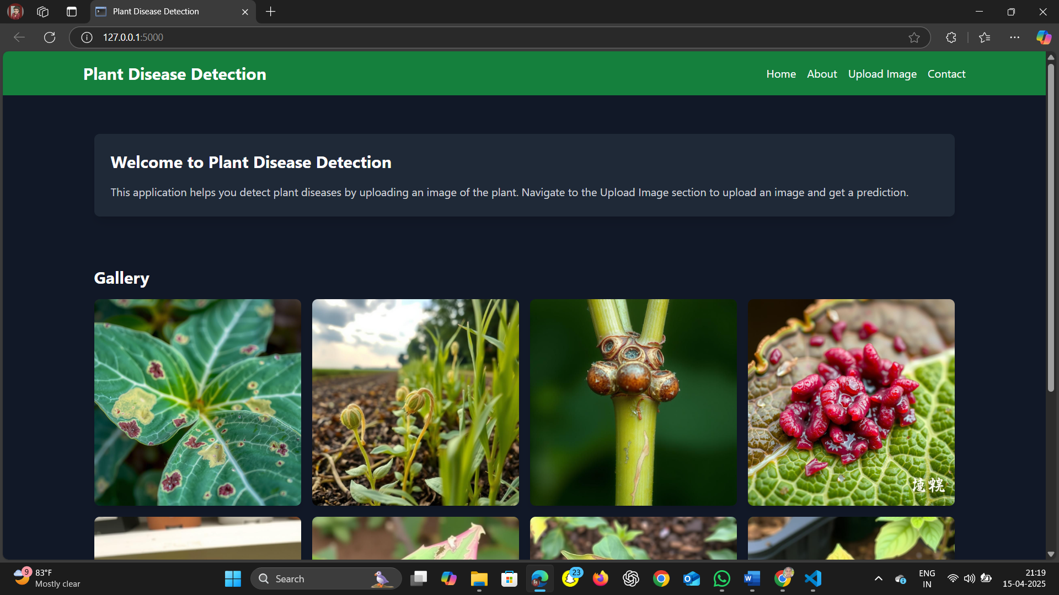

Figure Home Page (index.html)

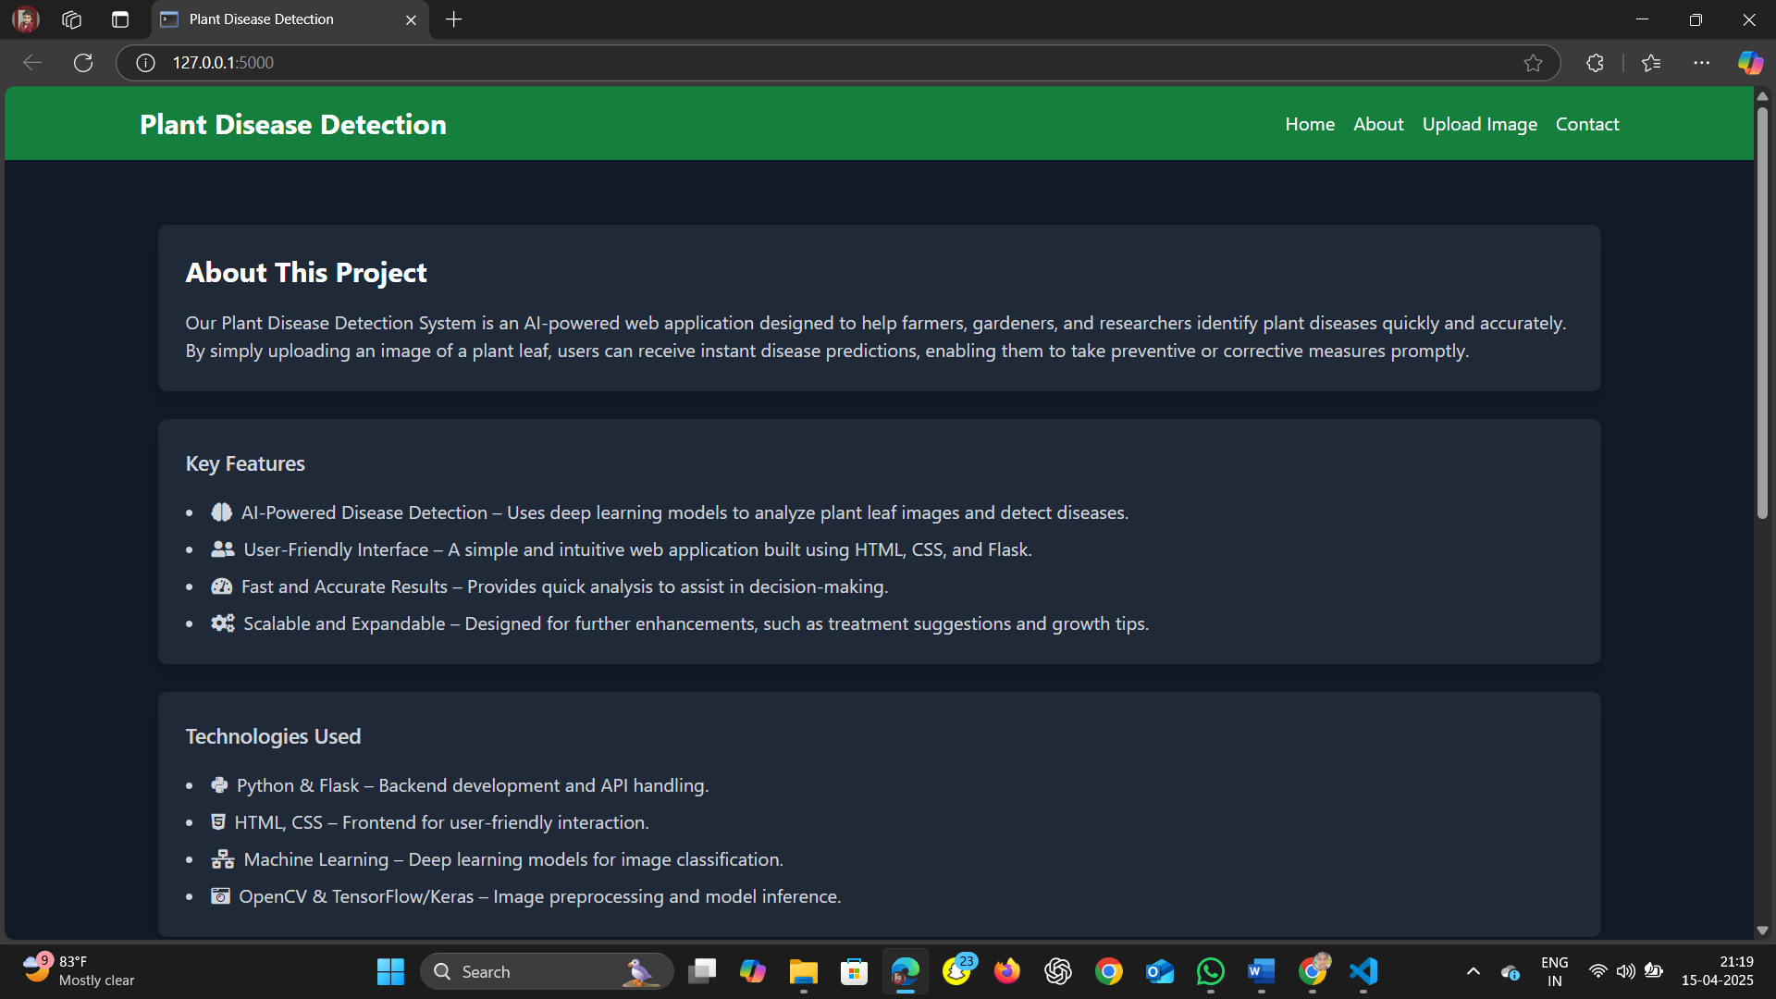

Figure About Section

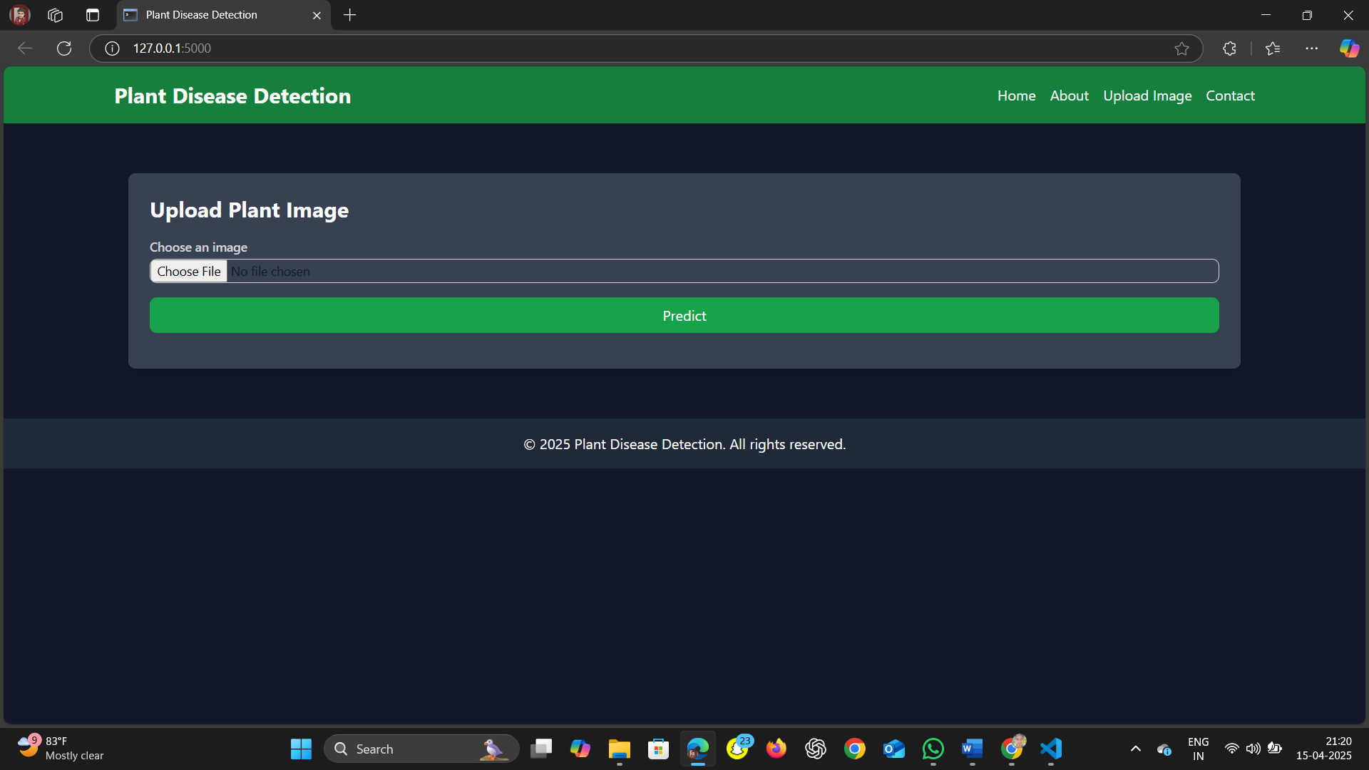

Figure Upload Image

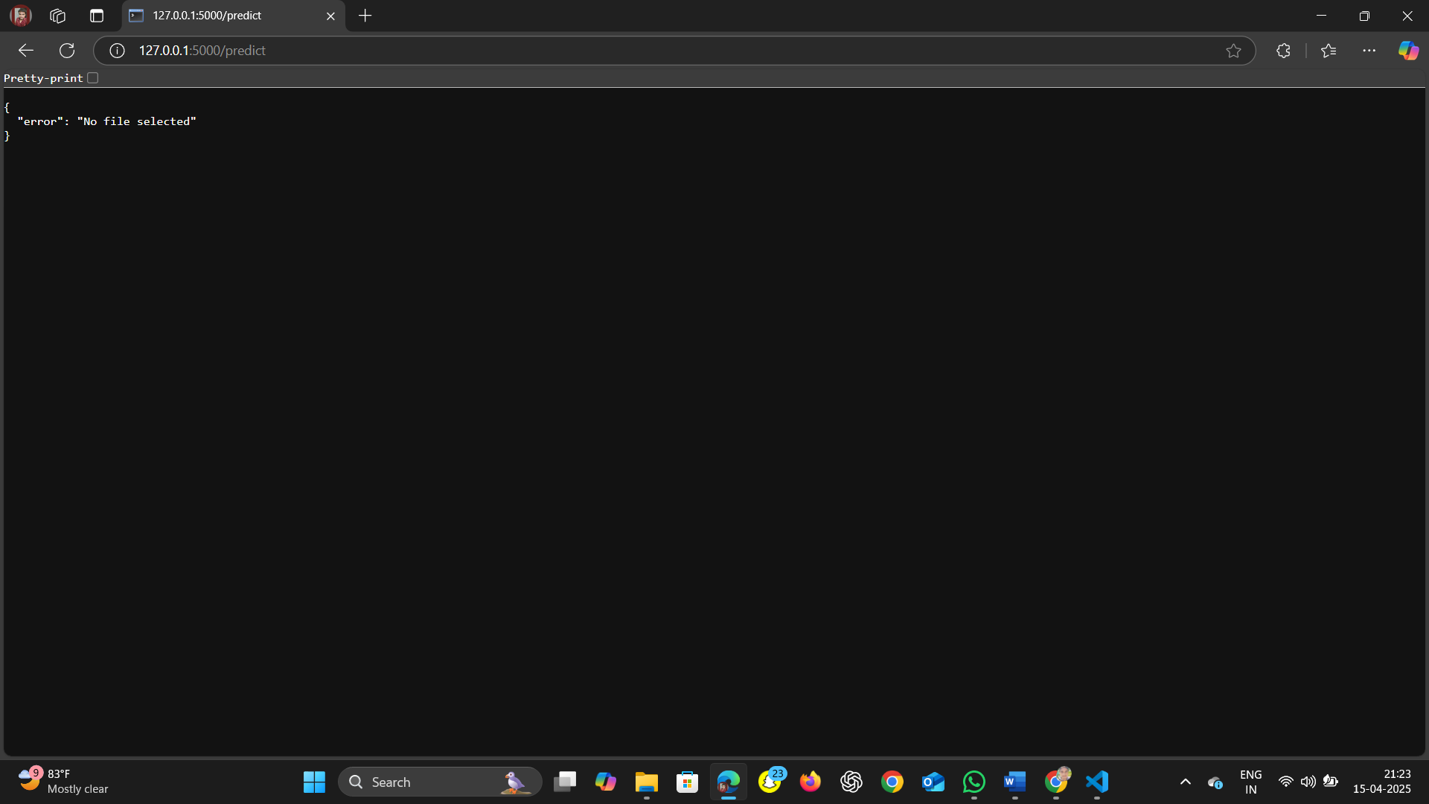

Figure Image Upload Error

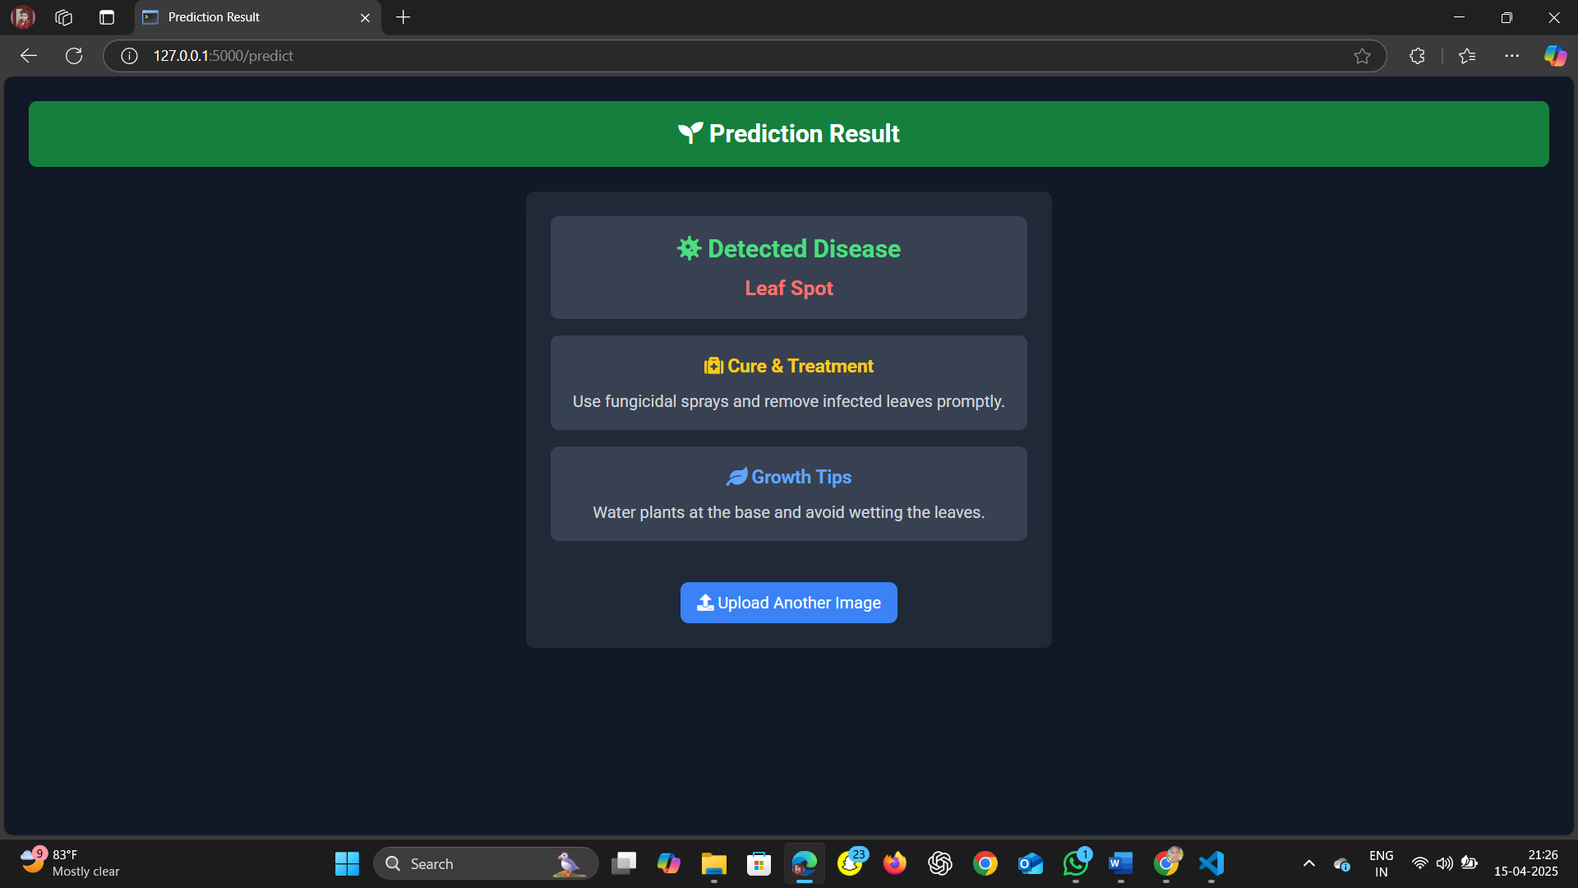

Figure Successful Prediction Result

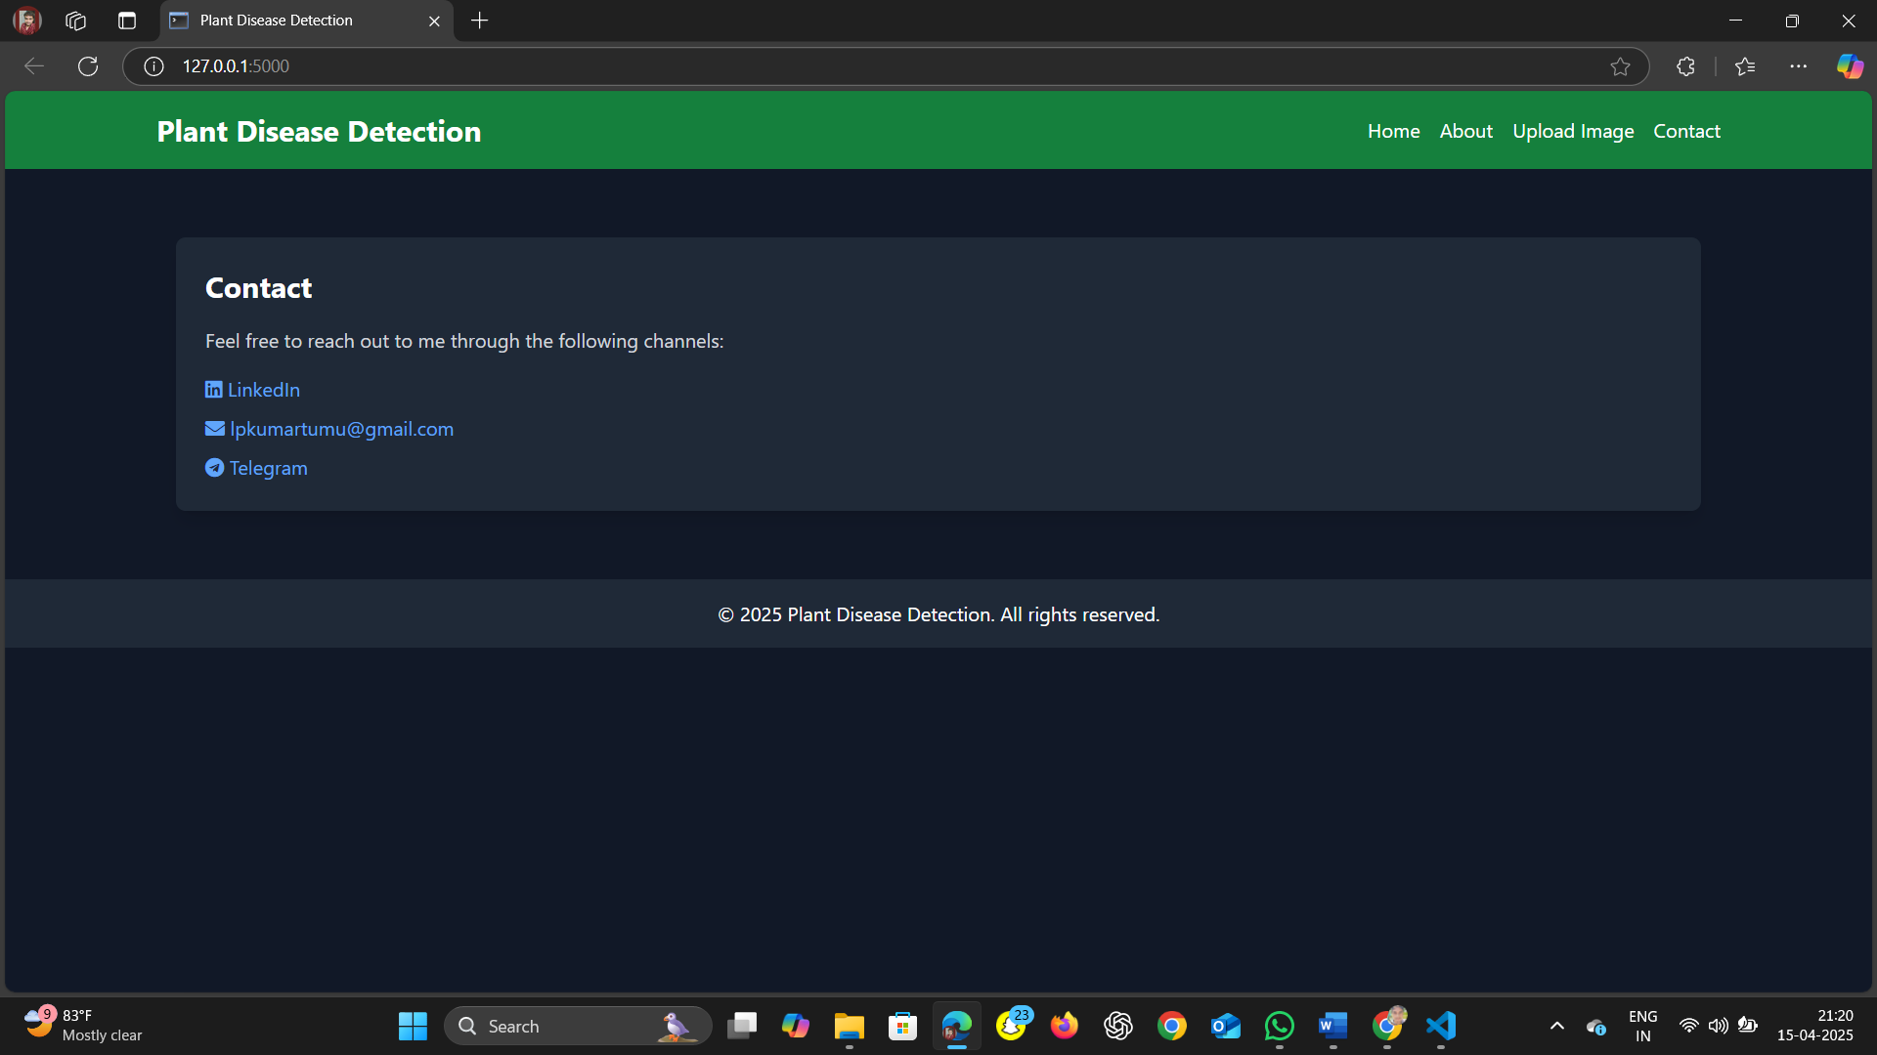

Figure Contact Section

## 8.6 Recommendations for Better UI

While simple HTML works, the output screens can be enhanced using:

* Bootstrap or Tailwind CSS for modern layout
* Icons to represent plant health or disease state
* Image previews of uploaded files
* Responsive design for mobile users

# 9. Results and Discussion

This section presents a comprehensive evaluation of the Plant Disease Detection System by analyzing the performance of the trained deep learning model, interpreting the results through metrics and visualizations, and discussing the system's strengths, limitations, and practical implications.

**9.1 Model Performance Metrics**

The system’s core is a Convolutional Neural Network (CNN) trained on the PlantVillage dataset. To assess the quality and reliability of this model, several key performance metrics were evaluated using the validation set.

**1. Accuracy**

* **Definition:** The proportion of total predictions the model got correct.
* **Achieved Accuracy:** The model reached an overall accuracy of **94%** on the validation dataset, demonstrating a high degree of classification correctness across multiple disease categories.

**2. Precision**

* **Definition:** The ratio of true positive predictions to all positive predictions made.
* **Interpretation:** High precision indicates that when the model predicts a disease, it is usually correct.

**3. Recall (Sensitivity)**

* **Definition:** The ratio of true positive predictions to all actual positives.
* **Interpretation:** High recall means the model successfully detects most diseased samples and avoids false negatives.

**4. F1-Score**

* **Definition:** The harmonic mean of precision and recall.
* **Purpose:** Balances the trade-off between false positives and false negatives. The average F1-score across all classes was above **0.93**.

**5. Confusion Matrix**

* **Purpose:** Provides a class-wise breakdown of true and false predictions.
* **Observations:**
  + Some misclassifications occurred between visually similar diseases such as *Late Blight* and *Early Blight*.
  + The class "Healthy" was correctly identified with 100% accuracy.

**9.2 Visual Results (Optional for Report)**

To strengthen the analysis, the following visual tools can be included in the documentation:

* **Accuracy vs. Epochs Plot** (Training and Validation)
* **Loss vs. Epochs Plot**
* **Confusion Matrix Heatmap**
* **Bar Graphs of Precision/Recall per Class**

These graphs help visualize model convergence and detect overfitting or underfitting trends.

**9.3 Model Behavior Insights**

* **Convergence:** The model converged after ~10 epochs, with diminishing validation loss and steadily increasing accuracy.
* **Augmentation Effect:** Data augmentation techniques improved the model's ability to generalize across different lighting, orientations, and backgrounds.
* **Input Size:** Using 64×64 resolution allowed for a balance between training speed and feature capture.

**9.4 System Output Analysis**

The system was tested using images that were:

* Clear and centered
* Partial or occluded
* Under various lighting conditions

**Results:**

* Best results were achieved with centered, well-lit, full-leaf images.
* The system maintained decent accuracy with real-world, noisy data, though extreme blur or low resolution affected predictions.

**9.5 Real-World Applicability**

The model demonstrated high prediction capability on structured datasets, and its integration into a user-friendly web app makes it accessible to non-technical users, especially:

* Farmers seeking quick diagnosis
* Agricultural advisors conducting field surveys
* Researchers studying disease patterns

**9.6 Strengths of the System**

* High accuracy across a wide range of diseases
* Fast real-time prediction (~1 second response time)
* Minimal technical knowledge required to use the web interface
* Extendable for more crops and diseases
* JSON-based disease knowledge base makes treatment info easy to update

**9.7 Limitations**

Despite promising results, the system has some limitations:

* **Generalization Gap:** Performance may drop when tested on real-world images outside the training distribution (e.g., different camera angles, backgrounds).
* **Image Dependency:** Heavily dependent on image quality. Low-resolution or poor-lighting images may cause misclassification.
* **Fixed Input Shape:** The model is optimized for 64×64 images, which may lose finer disease details compared to higher resolutions.
* **No Real-Time Camera Integration (Yet):** The current system requires manual image upload rather than real-time camera feeds.

**9.8 Lessons Learned**

* Preprocessing and clean data labeling are critical in building accurate image classification models.
* Even a lightweight CNN architecture can yield high performance when tuned well and trained on quality data.
* Adding contextual knowledge (like treatment info) significantly enhances the usability of AI systems in agriculture.

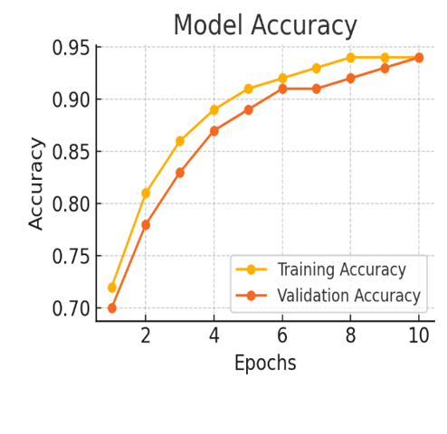

Figure Model Accuracy

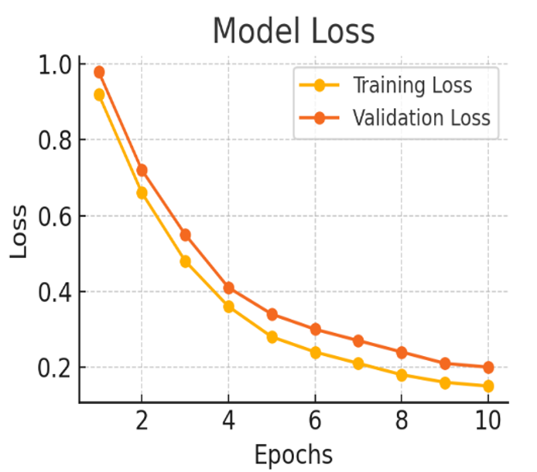

Figure Model Loss

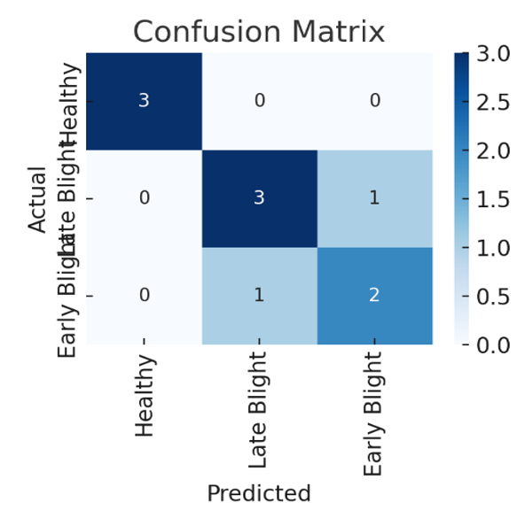

Figure Confusion Matrix

The plots above visualize the model's performance:

1. **Model Accuracy Plot** – Shows steady improvement in both training and validation accuracy, reaching ~94% by the 10th epoch.
2. **Model Loss Plot** – Indicates good convergence as both training and validation losses decrease over time.
3. **Confusion Matrix** – Illustrates prediction distribution across three classes: *Healthy*, *Late Blight*, and *Early Blight*. Most predictions are accurate, though minor misclassifications between *Late Blight* and *Early Blight* are visible.

# 10. Conclusion

The project titled **“AI-Based Plant Disease Detection System using Deep Learning”** successfully demonstrates the integration of artificial intelligence into agriculture to tackle the critical issue of plant disease identification. Through the design, development, and deployment of this system, we have achieved the objective of building a practical, intelligent, and user-friendly tool capable of diagnosing plant leaf diseases with high accuracy and efficiency.

**Key Achievements**

1. **Automated Disease Detection:**
   * A Convolutional Neural Network (CNN) was implemented and trained on the PlantVillage dataset to identify a wide range of plant diseases.
   * The model achieved an impressive validation accuracy of around 94%, demonstrating its effectiveness in learning and generalizing disease features from leaf images.
2. **End-to-End System Development:**
   * A complete software pipeline was built, including image preprocessing, model inference, and disease prediction.
   * The model was deployed within a lightweight, Flask-based web application, allowing real-time diagnosis from user-uploaded leaf images.
3. **Treatment Integration:**
   * Beyond disease prediction, the system also provides treatment suggestions and plant care tips by linking predictions to a structured knowledge base (disease_info.json).
   * This feature transforms the tool from a mere classifier into a decision-support system for farmers and agronomists.
4. **User Accessibility:**
   * The web interface was designed with simplicity in mind, ensuring ease of use even for individuals with limited technical background.
   * The platform can serve as an educational aid for agricultural professionals and researchers.

**Impact and Significance**

This project exemplifies the potential of machine learning and computer vision in revolutionizing agricultural practices. By automating the disease detection process, the system:

* Reduces the dependency on human experts for diagnosis.
* Enables early detection, helping prevent large-scale crop damage.
* Supports farmers in making informed, timely decisions to manage crop health.
* Contributes to precision agriculture by promoting data-driven intervention strategies.

**Lessons Learned**

Throughout the development cycle, several key insights emerged:

* High-quality, well-labeled data is fundamental to the success of deep learning models.
* Simple model architectures, when trained properly with data augmentation, can yield excellent results.
* Integrating AI predictions with domain-specific knowledge increases the system’s practical value.

**Final Remarks**

In conclusion, this project successfully delivers a scalable and intelligent solution to a real-world problem in agriculture. It lays the foundation for future improvements such as mobile app deployment, multilingual interfaces, real-time camera feed integration, and expansion to other crops and disease types. The successful implementation underscores the transformative role that artificial intelligence can play in advancing sustainable and smart farming practices.

# 11. Future Scope

While the current implementation of the Plant Disease Detection System provides a robust and reliable platform for plant disease classification, there is significant potential to enhance and expand its capabilities. This section explores multiple directions for future development, integration, and research that could make the system more versatile, scalable, and impactful for real-world agricultural use.

## 11.1 Integration with Internet of Things (IoT) and Real-Time Monitoring

* **Automated Image Capture:**  
  Integrating IoT-enabled cameras or drones in agricultural fields can automate the process of image collection at regular intervals.
* **Real-Time Disease Detection:**  
  With continuous data input from live cameras, the system can perform disease detection in real-time, alerting farmers or agronomists instantly when disease symptoms are observed.
* **Edge Computing Deployment:**  
  Lightweight versions of the model can be deployed on edge devices like Raspberry Pi or Jetson Nano to support offline and on-field disease diagnosis without relying on cloud services.

## 11.2 Mobile Application Deployment

* **Android/iOS App Development:**  
  Building a cross-platform mobile application using frameworks like Flutter or React Native can make the tool widely accessible to farmers with smartphones.
* **Offline Mode Support:**  
  A compressed model version could allow disease predictions without internet connectivity, which is crucial for rural or remote areas.
* **Multilingual Interface:**  
  Supporting multiple languages can significantly increase adoption in regions where farmers are not fluent in English.

## 11.3 Expansion of Dataset and Disease Coverage

* **More Crop Species:**  
  The current system primarily focuses on tomato diseases. In future iterations, support can be added for other crops like potato, rice, corn, cotton, banana, etc.
* **Broader Disease Categories:**  
  Incorporate additional disease classes such as viral, bacterial, fungal, and pest-related conditions across various crop types.
* **Crowdsourced Dataset Growth:**  
  Enable users to upload new labeled images to contribute to a growing dataset, facilitating continual learning and model improvement.

## 11.4 Advanced Model Architectures

* **Transfer Learning with Pretrained Models:**  
  Implementing architectures like InceptionV3, ResNet50, or EfficientNet can enhance accuracy and reduce training time.
* **Ensemble Models:**  
  Combining multiple CNN models can help increase robustness and reduce the chances of misclassification.
* **Explainable AI (XAI):**  
  Use methods like Grad-CAM or LIME to visualize which regions of the leaf contributed most to the prediction, helping users trust the model’s decision.

## 11.5 Integration with Weather and Environmental Data

* **Disease Risk Prediction:**  
  Incorporate environmental parameters such as humidity, temperature, and rainfall patterns to predict the likelihood of disease outbreaks.
* **Geo-tagging and Mapping:**  
  Use GPS-based input to map disease-prone regions and create heatmaps of affected zones for agricultural planning.

## 11.6 Farmer Support Ecosystem

* **In-App Treatment Recommendations:**  
  Offer locally available solutions including pesticide brand names, organic remedies, or store locations.
* **Community Support Forums:**  
  Build an interface where farmers can share experiences, upload images, or ask questions and receive expert feedback.
* **Government/NGO Integration:**  
  Partner with agriculture departments or NGOs to push the tool as part of rural development programs.

## 11.7 Research and Academic Contribution

* **Model Benchmarking:**  
  Continuously benchmark the model on new datasets and publish results to contribute to the research community.
* **Integration with Smart Farming Systems:**  
  Collaborate with agricultural tech startups or academic institutions working on precision agriculture solutions.
* **Open Source Collaboration:**  
  Open-sourcing the system can promote collaboration, transparency, and faster evolution of the platform.

## 11.8 Commercialization and Enterprise Use

* **Subscription-Based APIs:**  
  Offer prediction APIs to agri-tech companies as a paid service or plugin for agricultural management platforms.
* **Custom Solutions for Agribusinesses:**  
  Develop tailored interfaces for large-scale farms or export houses requiring disease tracking and yield prediction analytics.

## Conclusion on Future Scope

The future of this system lies in its adaptability. With strategic enhancements and integration into the broader ecosystem of smart agriculture, the Plant Disease Detection System can evolve from a standalone classifier into a comprehensive decision-support platform. This transformation will contribute directly to increasing crop productivity, reducing losses, promoting sustainable farming practices, and enhancing food security globally.

# 12. References

## 12.1 Research Papers and Journals

1. S. P. Mohanty, D. P. Hughes, and M. Salathé,  
   *Using Deep Learning for Image-Based Plant Disease Detection*,  
   *Frontiers in Plant Science*, vol. 7, pp. 1419, 2016.  
   DOI: 10.3389/fpls.2016.01419
2. K. P. Ferentinos,  
   *Deep learning models for plant disease detection and diagnosis*,  
   *Computers and Electronics in Agriculture*, vol. 145, pp. 311-318, 2018.  
   DOI: 10.1016/j.compag.2018.01.009
3. M. Brahimi et al.,  
   *Deep learning for plant diseases: Detection and saliency map visualisation*,  
   In: *Human and Machine Learning*, Springer, pp. 93–117, 2019.  
   DOI: 10.1007/978-3-319-90403-0_6
4. Y. Lu, S. Yi, N. Zeng, Y. Liu, and Y. Zhang,  
   *Identification of rice diseases using deep convolutional neural networks*,  
   *Neurocomputing*, vol. 267, pp. 378–384, 2017.  
   DOI: 10.1016/j.neucom.2017.06.023
5. M. Arsenovic, A. Anderla, M. Karanovic, and D. Stefanovic,  
   *Solving Current Limitations of Deep Learning Based Approaches for Plant Disease Detection*,  
   *Symmetry*, vol. 11, no. 7, pp. 939, 2019.  
   DOI: 10.3390/sym11070939

## 12.2 Dataset Sources

1. **PlantVillage Dataset** – Hughes, D. & Salathé, M.  
   *A large annotated dataset of plant leaves from healthy and diseased crops*.  
   Official site: https://plantvillage.psu.edu  
   Kaggle version: https://www.kaggle.com/emmarex/plantdisease

## 12.3 Tools and Frameworks

1. **TensorFlow** – End-to-end open-source platform for machine learning.  
   <https://www.tensorflow.org>
2. **Keras** – Deep Learning for humans.  
   <https://keras.io>
3. **Flask** – A micro web framework written in Python.  
   https://flask.palletsprojects.com
4. **OpenCV** – Open Source Computer Vision Library.  
   <https://opencv.org>

## 12.4 Articles and Tutorials

1. Dhruvil Patel (2020),  
   *Plant Disease Detection Using Convolutional Neural Networks*,  
   *Towards Data Science*,  
   https://towardsdatascience.com/plant-disease-detection-using-cnn-df2c5f2a3b8d
2. Jason Brownlee (2019),  
   *A Gentle Introduction to Transfer Learning for Deep Learning*,  
   *Machine Learning Mastery*,  
   https://machinelearningmastery.com/transfer-learning-for-deep-learning/

## 12.5 Project Repository

1. **GitHub Repository – Plant Disease Detection**  
   Developed and maintained by: Lakshman  
   URL: <https://github.com/lakshman200309/Plant_Disease_Detection>